VISTA: Verification using Intelligent Systems for Test Automation

Senior Design Project Report — Draft 3 (GIKI format structure)
Institute typography (apply in Microsoft Word per Vista_Report_format.txt): Title page — Times New Roman 18 pt bold (SDP title); student names and register numbers 14 pt bold; advisor, faculty, and institute names 14 pt bold; insert official university logo. Body text — Times New Roman 12 pt, 1.5 line spacing, justified. Abstract and Acknowledgements titles — 14 pt bold. Title page margins: Top 1.5″, Bottom 0.39″, Left 2″, Right 1.33″. Subsequent pages: Top and Bottom 1.5″, Left 2″, Right 1.33″; section start New Page where required. Paper: Letter (8.5″ × 11″), Portrait. Number equations consecutively as (1.1), (1.2), … with symbols per institute guidance. Figures: cite before insertion (e.g., Fig. 1.1); caption below figure (10 pt in final Word). Tables: head above table (10 pt). Submit through Turnitin as required.
Pagination estimate: This Markdown is written for expansion to approximately ninety printed pages after Word formatting, insertion of official title and certificate pages, list of figures/tables with page numbers, and optional blank verso pages. Actual page count depends on figure sizes and heading styles.

Title Page — Required content checklist
Element | Content
SDP title (18 pt bold) | VISTA: Verification using Intelligent Systems for Test Automation
Students (14 pt bold) | Asad Ali, Sheikh Abbas, Mian Arqam — add registration numbers
Advisor | Dr. Fahad Bin Muslim
Co-advisor | Dr. Waqar (if applicable)
Industrial mentors | Dr. Haroon, Dr. Majeed — NECOP
Faculty name (14 pt bold) | Faculty of Computer Engineering (verify official wording)
Institute (14 pt bold) | Ghulam Ishaq Khan Institute of Engineering Sciences and Technology (GIKI), Topi, Pakistan
Insert university logo on the bound title page.

Certificate of Approval
It is certified that the work presented in this report was performed by Asad Ali, Sheikh Abbas, and Mian Arqam under the supervision of Dr. Fahad Bin Muslim. The work is adequate and lies within the scope of the BS degree in Computer Engineering / Computer Science at Ghulam Ishaq Khan Institute of Engineering Sciences and Technology.
Industrial collaboration was supported by NECOP with mentorship from Dr. Haroon and Dr. Majeed.
Advisor | Co-Advisor (if applicable)
_________________________ | _________________________
Prof. Dr. Qadeer Ul Hassan
Dean
_________________________

SDGs Inclusion — goals aimed for and achievements

Sustainable Development Goal 4 — Quality education
Aim: Strengthen inclusive education and lifelong learning through engineering depth and reproducible teaching artifacts.
Achievement: VISTA packages a transparent pipeline from RTL fragments to formal checks, suitable for laboratory modules on assertion-based verification. Students can inspect inputs, outputs, and tool logs rather than treating the system as a black box.

Sustainable Development Goal 9 — Industry, innovation and infrastructure
Aim: Build resilient infrastructure and foster innovation.
Achievement: The work couples large language models with open-source formal tools (Yosys, SymbiYosys), lowering the barrier to rigorous property generation for research groups that lack commercial formal licenses.

Sustainable Development Goal 12 — Responsible consumption and production
Aim: Promote sustainable use of resources and energy.
Achievement: QLoRA fine-tuning reduces GPU memory footprint and training energy relative to full fine-tuning of an 8B-parameter base model, while retaining strong task performance on VERT-style assertion generation.

SDG signature block (per template): Advisor _________________ ; Co-Advisor _________________ .

ABSTRACT
Title (14 pt bold in Word): VISTA: Verification using Intelligent Systems for Test Automation
Hardware verification remains a dominant cost in modern integrated-circuit design. SystemVerilog Assertions (SVA) express temporal design intent for both simulation and formal analysis, yet manual assertion authoring is slow, expertise-intensive, and difficult to scale with design complexity. This report presents VISTA, an integrated framework that generates SVA-style properties directly from RTL fragments using a QLoRA-adapted LLaMA 3.1 (8B) model trained on the VERT corpus (twenty thousand labeled pairs in this repository). Because VERT samples are often non-modular snippets, VISTA introduces a dynamic wrapping stage that infers interface signals, applies clock and reset semantics, and produces elaboratable SystemVerilog suitable for Yosys and SymbiYosys. Deterministic post-processing extracts clean property structure, adapts expressions to the formal front end, and applies a greedy syntax filter that preserves as many clauses as possible while retaining parseability.
On a frozen evaluation of one hundred consecutive VERT records, all generated wrappers achieved Yosys syntax success, ninety-nine SymbiYosys bounded model-checking runs returned pass, and one returned fail. Mean gold Jaccard similarity to reference assertions was 0.991, with eighty-nine samples in the highest similarity bucket. The sole formal failure exhibits gold Jaccard 1.0, illustrating that lexical identity does not guarantee proof success when don’t-care bits appear in case selectors—a lesson in four-valued semantics and harness assumptions rather than a simple decoding error. A Next.js demonstration client and Python service support interactive use. The report concludes with limitations, ethics, and a roadmap toward counterexample-guided refinement.
Keywords: formal verification, SystemVerilog assertions, large language models, QLoRA, VERT, SymbiYosys, RTL wrapping, bounded model checking.

ACKNOWLEDGEMENTS
The authors express sincere gratitude to Dr. Fahad Bin Muslim for academic supervision and to Dr. Waqar for co-supervision where applicable. Industrial mentorship from Dr. Haroon and Dr. Majeed through NECOP provided valuable perspective on verification productivity and adoption. The open-source communities behind Yosys, SymbiYosys, Unsloth, and Hugging Face are thanked for maintaining reproducible tooling and documentation. Finally, the authors acknowledge the Faculty of Computer Engineering and GIKI for laboratory and computational resources.

TABLE OF CONTENTS
Microsoft Word: Map # CHAPTER … to Heading 1, ## Chapter n: … to Heading 3, and ### / #### to Heading 4–5 per Vista_Report_format.txt. Then use References → Table of Contents → Automatic and delete this manual listing or keep it as a planning outline and update TBD page cells after pagination.

Front matter (roman numerals on bound copy)
Ref | Section | Page
(i) | Title page — required content checklist | TBD
(ii) | Certificate of Approval | TBD
(iii) | SDGs Inclusion — goals and achievements | TBD
(iv) | ABSTRACT | TBD
(v) | ACKNOWLEDGEMENTS | TBD
(vi) | TABLE OF CONTENTS (this listing) | TBD
(vii) | LIST OF FIGURES | TBD
(viii) | LIST OF TABLES | TBD

CHAPTER I — Introduction
Ref | Section | Page
1.1 | Background and motivation | TBD
1.2 | Problem statement | TBD
1.3 | Objectives and scope | TBD
1.4 | Contributions | TBD
1.5 | Report organization | TBD
Fig. | Figures 1.1–1.3 (within Chapter I) | TBD

CHAPTER II — Literature survey
Ref | Section | Page
2.1 | Overview | TBD
2.2 | Foundational themes (diagrams) | TBD
2.3 | Model checking and temporal logics | TBD
2.4 | SAT-based and SMT-based bounded model checking | TBD
2.5 | Inductive proof obligations and k-induction | TBD
2.6 | SystemVerilog assertions in industrial flows | TBD
2.7 | Assertion mining from simulation traces | TBD
2.8 | Static analysis and invariant inference | TBD
2.9 | GoldMine-style property discovery | TBD
2.10 | Natural-language to assertion translation | TBD
2.11 | Waveform-assisted assertion learning | TBD
2.12 | Knowledge graphs and design intent alignment | TBD
2.13 | AssertionBench and comparable benchmarks | TBD
2.14 | The VERT corpus and fragment-level RTL | TBD
2.15 | Open-source formal stacks (Yosys, SymbiYosys) | TBD
2.16 | Vacuity, coverage, and meaningful formal results | TBD
2.17 | Reset and initialization assumptions in BMC | TBD
2.18 | Clock-domain alignment for concurrent assertions | TBD
2.19 | Four-valued logic and X-propagation in formal runs | TBD
2.20 | Parameter-efficient fine-tuning survey | TBD
2.21 | QLoRA and memory-efficient adaptation | TBD
2.22 | Instruction tuning for code and hardware domains | TBD
2.23 | Evaluation contamination and benchmark hygiene | TBD
2.24 | Reproducibility in ML-for-EDA research | TBD
2.25 | Industrial adoption barriers for formal methods | TBD
2.26 | NECOP-relevant verification productivity themes | TBD
2.27 | Energy footprint of large-model training | TBD
2.28 | Security of RTL when using local vs cloud inference | TBD
2.29 | Documentation and traceability for student projects | TBD
2.30 | Limitations of lexical similarity metrics | TBD
2.31 | Counterexample-guided assertion refinement | TBD
2.32 | Assume–guarantee and modular verification outlook | TBD
II–S1 | Supplement: Industrial verification metrics beyond pass rate | TBD
II–S2 | Supplement: Regression hygiene for ML-assisted flows | TBD
II–S3 | Supplement: Cross-corpus transfer and domain shift | TBD
II–S4 | Supplement: Replicability of OSS CAD versions | TBD
II–S5 | Supplement: Peer review expectations for ML-for-EDA | TBD
II–S6 | Supplement: Documentation standards for FYP repositories | TBD
II–S7 | Supplement: Turnitin and originality checks prior to submission | TBD
II–S8 | Supplement: Defense materials alignment with thesis claims | TBD

CHAPTER III — Design (requirements / specifications)
Ref | Section | Page
3.1 | System context | TBD
3.2 | Functional requirements (Table 3.1) | TBD
3.3 | Non-functional requirements (Table 3.2) | TBD
Fig. | Figures 3.1–3.3 | TBD

CHAPTER IV — Proposed solution (methodology, implementation)
Ref | Section | Page
4.1 | Scientific method and reproducibility | TBD
4.2 | Dataset and training configuration (Table 4.1) | TBD
4.3 | Core methodology narrative | TBD
Fig. | Figures 4.1–4.8 | TBD
4.4 | Dataset curation and VERT record schema | TBD
4.5 | Train/validation partitioning and leakage control | TBD
4.6 | Prompt design and instruction–response alignment | TBD
4.7 | Tokenization effects on hardware identifiers | TBD
4.8 | LoRA adapter placement and trainable blocks | TBD
4.9 | Optimizer choice and learning-rate schedules | TBD
4.10 | Gradient accumulation and effective batch size | TBD
4.11 | Mixed precision and numerical stability | TBD
4.12 | Checkpoint selection and early stopping heuristics | TBD
4.13 | Greedy decoding versus sampling for verification | TBD
4.14 | Assertion extraction from verbose model outputs | TBD
4.15 | Syntax sanitization for formal front ends | TBD
4.16 | Temporal lowering and tool dialect mismatches | TBD
4.17 | Greedy subset selection under parse constraints | TBD
4.18 | Signal inference from RTL and assertion text | TBD
4.19 | Keyword filtering and false signal candidates | TBD
4.20 | Synchronous harness construction and two-phase updates | TBD
4.21 | Combinational harness construction with always_comb semantics | TBD
4.22 | First-cycle gating and vacuity mitigation | TBD
4.23 | SymbiYosys engine configuration and proof depth | TBD
4.24 | Per-case artifacts and regression packaging | TBD
4.25 | Web demonstration architecture and separation of concerns | TBD
4.26 | Operational security for proprietary RTL | TBD
IV–M1 | Supplement: Logging and experiment tracking practices | TBD
IV–M2 | Supplement: Version pinning for PyTorch and CUDA drivers | TBD
IV–M3 | Supplement: Timeout policies for long-running formal jobs | TBD
IV–M4 | Supplement: Unit tests for parsing and extraction | TBD
IV–M5 | Supplement: Continuous integration for evaluation scripts | TBD
IV–M6 | Supplement: Checksum verification for datasets | TBD

CHAPTER V — Results and discussion
Ref | Section | Page
5.1 | Metrics and equation for gold Jaccard | TBD
5.2 | Aggregate results (Table 5.1) | TBD
5.3 | Distribution of gold Jaccard (Table 5.2) | TBD
5.4 | Discussion of formal failure (sample 82) | TBD
Fig. | Figures 5.1–5.4 | TBD
5.6 | Reporting syntax success versus semantic proof | TBD
5.7 | Interpreting SymbiYosys pass and fail verdicts | TBD
5.8 | Gold Jaccard as a lexical alignment metric | TBD
5.9 | Correlation between Jaccard and formal pass rate | TBD
5.10 | Outlier analysis for low-Jaccard samples | TBD
5.11 | Formal failure with high Jaccard: case semantics | TBD
5.12 | Effect of greedy assertion filtering on yield | TBD
5.13 | Clause-level counts and aggregation in the manifest | TBD
5.14 | Bounded depth and completeness caveats | TBD
5.15 | Threats to internal validity of the evaluation slice | TBD
5.16 | Threats to external validity beyond VERT | TBD
5.17 | Comparison to AssertionBench-style claims | TBD
5.18 | Industrial metrics: review effort and time saved | TBD
5.19 | Reproducibility checklist for independent auditors | TBD
5.20 | Future statistical tests and confidence intervals | TBD
V–R1 | Supplement: Replication package structure for conferences | TBD
V–R2 | Supplement: Archiving SymbiYosys logs for long-term audit | TBD
V–R3 | Supplement: Redaction of proprietary RTL in appendices | TBD

CHAPTER VI — Conclusion and future work
Ref | Section | Page
6.1 | Conclusion | TBD
6.2 | Future work | TBD
Fig. | Figure 6.1 — roadmap | TBD

Back matter
Ref | Section | Page
— | Glossary (49 entries) | TBD
— | References | TBD
App. A | Institute formatting checklist | TBD
App. B | Reproducibility statement | TBD
App. C | Ethics, risk, limitations + Table A.1 outliers | TBD
App. D | Threats to validity | TBD
App. E | Table B.1 — Per-sample log (n = 100) | TBD

LIST OF FIGURES
Format per institute template (Number — Caption — Page). Page numbers are placeholders (TBD).
Fig. | Caption | Page
1.1 | Verification lifecycle and VISTA placement | TBD
1.2 | Stakeholder map | TBD
1.3 | SDG contribution mapping | TBD
2.1 | Research timeline (themes) | TBD
2.2 | Sources of assertion knowledge | TBD
2.3 | Formal verification stack layers | TBD
2.4 | Positioning: NL-driven vs RTL-only generation | TBD
3.1 | System boundary and external interfaces | TBD
3.2 | Functional requirements traceability | TBD
3.3 | Non-functional requirement categories | TBD
4.1 | End-to-end methodology overview | TBD
4.2 | Dataset and training data flow | TBD
4.3 | QLoRA adaptation concept | TBD
4.4 | Inference and service interaction (sequence) | TBD
4.5 | Post-processing and filter stages | TBD
4.6 | Synchronous wrapper and clock alignment | TBD
4.7 | Evaluation harness and artifacts | TBD
4.8 | Demonstration deployment layers | TBD
5.1 | Evaluation workflow from record to verdict | TBD
5.2 | Aggregate syntax and formal outcomes (n = 100) | TBD
5.3 | Gold Jaccard distribution | TBD
5.4 | Interpreting pass vs fail vs lexical match | TBD
6.1 | Research and engineering roadmap | TBD

LIST OF TABLES
Table | Caption | Page
3.1 | Functional requirements summary | TBD
3.2 | Non-functional requirements summary | TBD
4.1 | Training hyperparameters (project defaults) | TBD
5.1 | Aggregate metrics (model_eval_v7_100) | TBD
5.2 | Gold Jaccard buckets | TBD
A.1 | Outlier cases (formal fail or Jaccard < 0.95) | TBD
B.1 | Per-sample evaluation log (n = 100) | TBD

CHAPTER I

Chapter 1: Introduction

1.1 Background and motivation
Register-transfer level (RTL) design captures the structure and cycle-accurate behavior of digital hardware before fabrication. Verification—demonstrating that the RTL satisfies intent under stated assumptions—consumes a large fraction of project schedule and staffing. Assertions operationalize intent: they can be simulated, constrained in randomized testbenches, and, when supported, analyzed by formal engines. SystemVerilog Assertions are the de facto standard for expressing temporal properties in modern digital flows.
Despite mature tooling, teams still struggle to write enough high-quality assertions early enough. Manual authoring is error-prone; reviews are expensive; and knowledge is uneven across sites. Machine learning, and specifically large language models, offer a complementary path: learn regularities from corpora of RTL and assertions, then propose candidate properties for engineer review. The scientific question is how to connect such proposals to credible verification outcomes rather than anecdotal demos.

1.2 Problem statement
The VERT dataset provides paired RTL fragments and reference assertions together with synchronization and clock metadata. However, VERT fragments are not necessarily complete modules; open formal flows expect declarations, consistent clocking, and parseable SVA. The core problem addressed here is therefore threefold: (i) generate assertion text aligned with VERT’s distribution; (ii) normalize and repair model outputs for tool consumption; and (iii) wrap fragments into a harness that supports reproducible bounded proofs.

1.3 Objectives and scope
Objectives: (1) fine-tune an 8B-class LLM with QLoRA for RTL-to-assertion generation; (2) implement post-processing and a dynamic wrapper; (3) evaluate with Yosys and SymbiYosys on a fixed hundred-sample slice; (4) deliver a demonstration interface.
Scope: VERT-style control-flow fragments, local or laboratory GPU inference, and OSS formal tools. Out of scope: full-chip hierarchical verification sign-off, analog/mixed-signal, and proprietary timing closure.

1.4 Contributions
The project contributes an end-to-end pipeline, a reproducible evaluation snapshot, and an honest discussion of failure modes—including a formal failure with perfect lexical agreement—highlighting semantics and assumptions.

1.5 Report organization
Chapter II reviews literature. Chapter III specifies requirements. Chapter IV details methodology and implementation. Chapter V presents results. Chapter VI concludes. Glossary, references, and appendices follow.
Fig. 1.1 — Verification lifecycle and placement of VISTA.
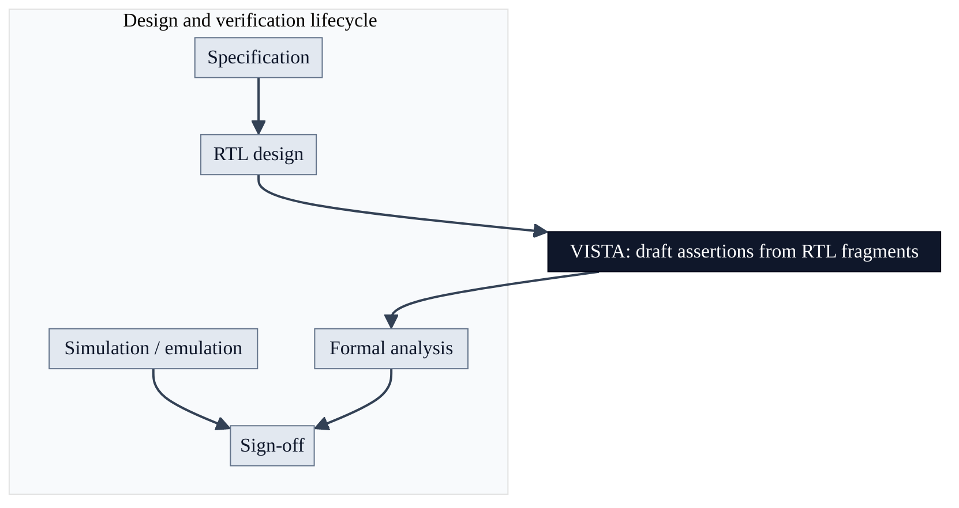
Figure 1 — diagram
Fig. 1.2 — Primary stakeholders.
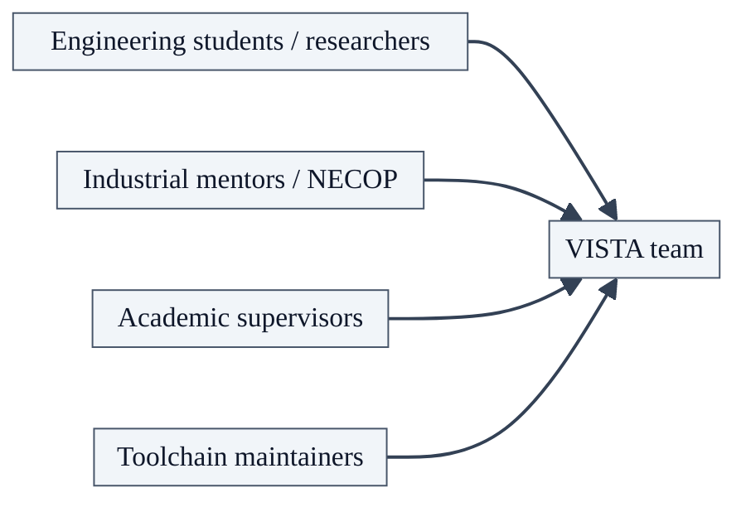
Figure 2 — diagram
Fig. 1.3 — SDG contribution mapping.

Figure 3 — diagram

CHAPTER II

Chapter 2: Literature survey

2.1 Overview
This chapter situates VISTA within formal methods, assertion generation research, benchmarking practice, and parameter-efficient learning. Each following subsection deepens one theme and cites where the thesis should connect to primary literature in IEEE format.

2.2 Foundational themes (diagrams)
Fig. 2.1 — Thematic timeline (conceptual).
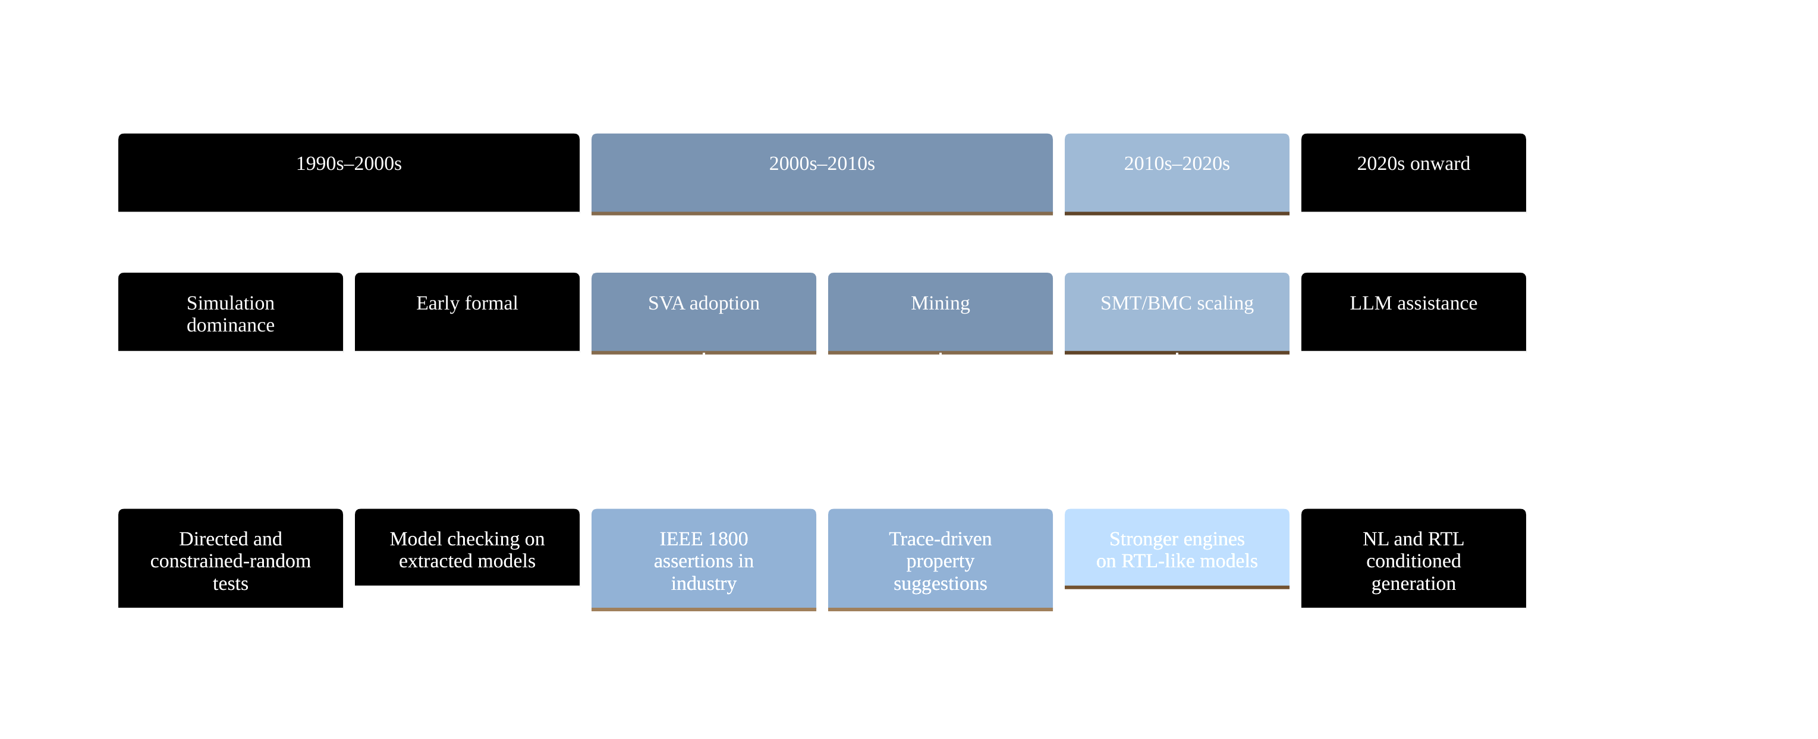
Figure 4 — diagram
Fig. 2.2 — Where assertion knowledge can originate.
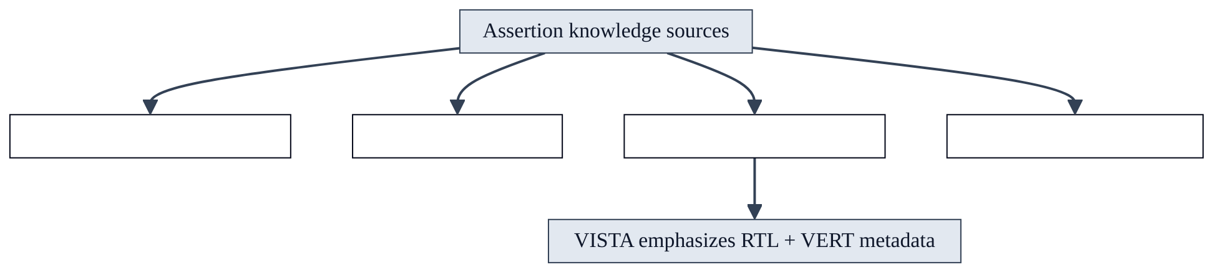
Figure 5 — diagram
Fig. 2.3 — Layered formal verification stack (simplified).
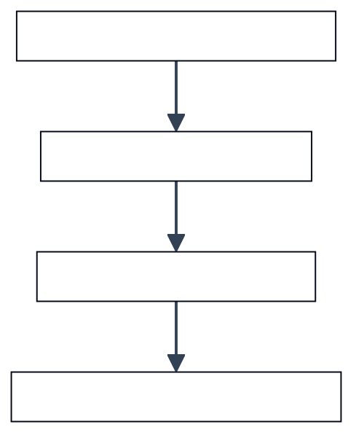
Figure 6 — diagram
Fig. 2.4 — NL-driven vs RTL-only assertion generation (positioning).
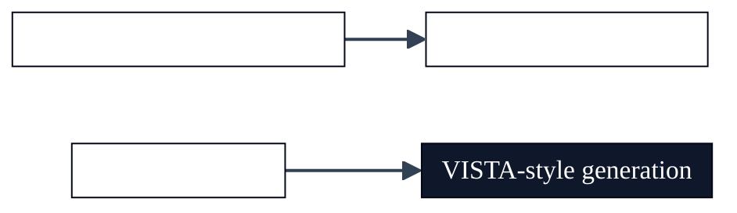
Figure 7 — diagram

2.3 Model checking and temporal logics
This subsection discusses Model checking and temporal logics as it relates to Chapter II (literature survey). Hardware verification research consistently shows that assertion quality—not raw engine throughput—often limits effective defect discovery. Automated generators must therefore be judged along multiple axes: syntactic acceptability, semantic alignment with designer intent on benchmark corpora, and stability under formal encodings that expose corner cases such as unknown bits and reset interactions. Review committees additionally expect clarity on dataset provenance, train–test overlap risks, and whether metrics are reported on a frozen slice or on a continuously moving checkpoint.
Within Model checking and temporal logics, the VISTA project adopts a pragmatic stance aligned with open-source tooling: the VERT distribution supplies paired RTL and reference assertions, while SymbiYosys supplies bounded checks that are easy to reproduce in academic laboratories. This does not replace industrial sign-off flows; it provides a transparent yardstick for iterative model and pipeline improvements. Students extending this report should cite peer-reviewed and standard references in IEEE format, critique assumptions explicitly, and avoid overstating claims beyond the frozen evaluation slice reported in Chapter V.

2.4 SAT-based and SMT-based bounded model checking
This subsection discusses SAT-based and SMT-based bounded model checking as it relates to Chapter II (literature survey). Hardware verification research consistently shows that assertion quality—not raw engine throughput—often limits effective defect discovery. Automated generators must therefore be judged along multiple axes: syntactic acceptability, semantic alignment with designer intent on benchmark corpora, and stability under formal encodings that expose corner cases such as unknown bits and reset interactions. Review committees additionally expect clarity on dataset provenance, train–test overlap risks, and whether metrics are reported on a frozen slice or on a continuously moving checkpoint.
Within SAT-based and SMT-based bounded model checking, the VISTA project adopts a pragmatic stance aligned with open-source tooling: the VERT distribution supplies paired RTL and reference assertions, while SymbiYosys supplies bounded checks that are easy to reproduce in academic laboratories. This does not replace industrial sign-off flows; it provides a transparent yardstick for iterative model and pipeline improvements. Students extending this report should cite peer-reviewed and standard references in IEEE format, critique assumptions explicitly, and avoid overstating claims beyond the frozen evaluation slice reported in Chapter V.

2.5 Inductive proof obligations and k-induction
This subsection discusses Inductive proof obligations and k-induction as it relates to Chapter II (literature survey). Hardware verification research consistently shows that assertion quality—not raw engine throughput—often limits effective defect discovery. Automated generators must therefore be judged along multiple axes: syntactic acceptability, semantic alignment with designer intent on benchmark corpora, and stability under formal encodings that expose corner cases such as unknown bits and reset interactions. Review committees additionally expect clarity on dataset provenance, train–test overlap risks, and whether metrics are reported on a frozen slice or on a continuously moving checkpoint.
Within Inductive proof obligations and k-induction, the VISTA project adopts a pragmatic stance aligned with open-source tooling: the VERT distribution supplies paired RTL and reference assertions, while SymbiYosys supplies bounded checks that are easy to reproduce in academic laboratories. This does not replace industrial sign-off flows; it provides a transparent yardstick for iterative model and pipeline improvements. Students extending this report should cite peer-reviewed and standard references in IEEE format, critique assumptions explicitly, and avoid overstating claims beyond the frozen evaluation slice reported in Chapter V.

2.6 SystemVerilog assertions in industrial flows
This subsection discusses SystemVerilog assertions in industrial flows as it relates to Chapter II (literature survey). Hardware verification research consistently shows that assertion quality—not raw engine throughput—often limits effective defect discovery. Automated generators must therefore be judged along multiple axes: syntactic acceptability, semantic alignment with designer intent on benchmark corpora, and stability under formal encodings that expose corner cases such as unknown bits and reset interactions. Review committees additionally expect clarity on dataset provenance, train–test overlap risks, and whether metrics are reported on a frozen slice or on a continuously moving checkpoint.
Within SystemVerilog assertions in industrial flows, the VISTA project adopts a pragmatic stance aligned with open-source tooling: the VERT distribution supplies paired RTL and reference assertions, while SymbiYosys supplies bounded checks that are easy to reproduce in academic laboratories. This does not replace industrial sign-off flows; it provides a transparent yardstick for iterative model and pipeline improvements. Students extending this report should cite peer-reviewed and standard references in IEEE format, critique assumptions explicitly, and avoid overstating claims beyond the frozen evaluation slice reported in Chapter V.

2.7 Assertion mining from simulation traces
This subsection discusses Assertion mining from simulation traces as it relates to Chapter II (literature survey). Hardware verification research consistently shows that assertion quality—not raw engine throughput—often limits effective defect discovery. Automated generators must therefore be judged along multiple axes: syntactic acceptability, semantic alignment with designer intent on benchmark corpora, and stability under formal encodings that expose corner cases such as unknown bits and reset interactions. Review committees additionally expect clarity on dataset provenance, train–test overlap risks, and whether metrics are reported on a frozen slice or on a continuously moving checkpoint.
Within Assertion mining from simulation traces, the VISTA project adopts a pragmatic stance aligned with open-source tooling: the VERT distribution supplies paired RTL and reference assertions, while SymbiYosys supplies bounded checks that are easy to reproduce in academic laboratories. This does not replace industrial sign-off flows; it provides a transparent yardstick for iterative model and pipeline improvements. Students extending this report should cite peer-reviewed and standard references in IEEE format, critique assumptions explicitly, and avoid overstating claims beyond the frozen evaluation slice reported in Chapter V.

2.8 Static analysis and invariant inference
This subsection discusses Static analysis and invariant inference as it relates to Chapter II (literature survey). Hardware verification research consistently shows that assertion quality—not raw engine throughput—often limits effective defect discovery. Automated generators must therefore be judged along multiple axes: syntactic acceptability, semantic alignment with designer intent on benchmark corpora, and stability under formal encodings that expose corner cases such as unknown bits and reset interactions. Review committees additionally expect clarity on dataset provenance, train–test overlap risks, and whether metrics are reported on a frozen slice or on a continuously moving checkpoint.
Within Static analysis and invariant inference, the VISTA project adopts a pragmatic stance aligned with open-source tooling: the VERT distribution supplies paired RTL and reference assertions, while SymbiYosys supplies bounded checks that are easy to reproduce in academic laboratories. This does not replace industrial sign-off flows; it provides a transparent yardstick for iterative model and pipeline improvements. Students extending this report should cite peer-reviewed and standard references in IEEE format, critique assumptions explicitly, and avoid overstating claims beyond the frozen evaluation slice reported in Chapter V.

2.9 GoldMine-style property discovery
This subsection discusses GoldMine-style property discovery as it relates to Chapter II (literature survey). Hardware verification research consistently shows that assertion quality—not raw engine throughput—often limits effective defect discovery. Automated generators must therefore be judged along multiple axes: syntactic acceptability, semantic alignment with designer intent on benchmark corpora, and stability under formal encodings that expose corner cases such as unknown bits and reset interactions. Review committees additionally expect clarity on dataset provenance, train–test overlap risks, and whether metrics are reported on a frozen slice or on a continuously moving checkpoint.
Within GoldMine-style property discovery, the VISTA project adopts a pragmatic stance aligned with open-source tooling: the VERT distribution supplies paired RTL and reference assertions, while SymbiYosys supplies bounded checks that are easy to reproduce in academic laboratories. This does not replace industrial sign-off flows; it provides a transparent yardstick for iterative model and pipeline improvements. Students extending this report should cite peer-reviewed and standard references in IEEE format, critique assumptions explicitly, and avoid overstating claims beyond the frozen evaluation slice reported in Chapter V.

2.10 Natural-language to assertion translation
This subsection discusses Natural-language to assertion translation as it relates to Chapter II (literature survey). Hardware verification research consistently shows that assertion quality—not raw engine throughput—often limits effective defect discovery. Automated generators must therefore be judged along multiple axes: syntactic acceptability, semantic alignment with designer intent on benchmark corpora, and stability under formal encodings that expose corner cases such as unknown bits and reset interactions. Review committees additionally expect clarity on dataset provenance, train–test overlap risks, and whether metrics are reported on a frozen slice or on a continuously moving checkpoint.
Within Natural-language to assertion translation, the VISTA project adopts a pragmatic stance aligned with open-source tooling: the VERT distribution supplies paired RTL and reference assertions, while SymbiYosys supplies bounded checks that are easy to reproduce in academic laboratories. This does not replace industrial sign-off flows; it provides a transparent yardstick for iterative model and pipeline improvements. Students extending this report should cite peer-reviewed and standard references in IEEE format, critique assumptions explicitly, and avoid overstating claims beyond the frozen evaluation slice reported in Chapter V.

2.11 Waveform-assisted assertion learning
This subsection discusses Waveform-assisted assertion learning as it relates to Chapter II (literature survey). Hardware verification research consistently shows that assertion quality—not raw engine throughput—often limits effective defect discovery. Automated generators must therefore be judged along multiple axes: syntactic acceptability, semantic alignment with designer intent on benchmark corpora, and stability under formal encodings that expose corner cases such as unknown bits and reset interactions. Review committees additionally expect clarity on dataset provenance, train–test overlap risks, and whether metrics are reported on a frozen slice or on a continuously moving checkpoint.
Within Waveform-assisted assertion learning, the VISTA project adopts a pragmatic stance aligned with open-source tooling: the VERT distribution supplies paired RTL and reference assertions, while SymbiYosys supplies bounded checks that are easy to reproduce in academic laboratories. This does not replace industrial sign-off flows; it provides a transparent yardstick for iterative model and pipeline improvements. Students extending this report should cite peer-reviewed and standard references in IEEE format, critique assumptions explicitly, and avoid overstating claims beyond the frozen evaluation slice reported in Chapter V.

2.12 Knowledge graphs and design intent alignment
This subsection discusses Knowledge graphs and design intent alignment as it relates to Chapter II (literature survey). Hardware verification research consistently shows that assertion quality—not raw engine throughput—often limits effective defect discovery. Automated generators must therefore be judged along multiple axes: syntactic acceptability, semantic alignment with designer intent on benchmark corpora, and stability under formal encodings that expose corner cases such as unknown bits and reset interactions. Review committees additionally expect clarity on dataset provenance, train–test overlap risks, and whether metrics are reported on a frozen slice or on a continuously moving checkpoint.
Within Knowledge graphs and design intent alignment, the VISTA project adopts a pragmatic stance aligned with open-source tooling: the VERT distribution supplies paired RTL and reference assertions, while SymbiYosys supplies bounded checks that are easy to reproduce in academic laboratories. This does not replace industrial sign-off flows; it provides a transparent yardstick for iterative model and pipeline improvements. Students extending this report should cite peer-reviewed and standard references in IEEE format, critique assumptions explicitly, and avoid overstating claims beyond the frozen evaluation slice reported in Chapter V.

2.13 AssertionBench and comparable benchmarks
This subsection discusses AssertionBench and comparable benchmarks as it relates to Chapter II (literature survey). Hardware verification research consistently shows that assertion quality—not raw engine throughput—often limits effective defect discovery. Automated generators must therefore be judged along multiple axes: syntactic acceptability, semantic alignment with designer intent on benchmark corpora, and stability under formal encodings that expose corner cases such as unknown bits and reset interactions. Review committees additionally expect clarity on dataset provenance, train–test overlap risks, and whether metrics are reported on a frozen slice or on a continuously moving checkpoint.
Within AssertionBench and comparable benchmarks, the VISTA project adopts a pragmatic stance aligned with open-source tooling: the VERT distribution supplies paired RTL and reference assertions, while SymbiYosys supplies bounded checks that are easy to reproduce in academic laboratories. This does not replace industrial sign-off flows; it provides a transparent yardstick for iterative model and pipeline improvements. Students extending this report should cite peer-reviewed and standard references in IEEE format, critique assumptions explicitly, and avoid overstating claims beyond the frozen evaluation slice reported in Chapter V.

2.14 The VERT corpus and fragment-level RTL
This subsection discusses The VERT corpus and fragment-level RTL as it relates to Chapter II (literature survey). Hardware verification research consistently shows that assertion quality—not raw engine throughput—often limits effective defect discovery. Automated generators must therefore be judged along multiple axes: syntactic acceptability, semantic alignment with designer intent on benchmark corpora, and stability under formal encodings that expose corner cases such as unknown bits and reset interactions. Review committees additionally expect clarity on dataset provenance, train–test overlap risks, and whether metrics are reported on a frozen slice or on a continuously moving checkpoint.
Within The VERT corpus and fragment-level RTL, the VISTA project adopts a pragmatic stance aligned with open-source tooling: the VERT distribution supplies paired RTL and reference assertions, while SymbiYosys supplies bounded checks that are easy to reproduce in academic laboratories. This does not replace industrial sign-off flows; it provides a transparent yardstick for iterative model and pipeline improvements. Students extending this report should cite peer-reviewed and standard references in IEEE format, critique assumptions explicitly, and avoid overstating claims beyond the frozen evaluation slice reported in Chapter V.

2.15 Open-source formal stacks (Yosys, SymbiYosys)
This subsection discusses Open-source formal stacks (Yosys, SymbiYosys) as it relates to Chapter II (literature survey). Hardware verification research consistently shows that assertion quality—not raw engine throughput—often limits effective defect discovery. Automated generators must therefore be judged along multiple axes: syntactic acceptability, semantic alignment with designer intent on benchmark corpora, and stability under formal encodings that expose corner cases such as unknown bits and reset interactions. Review committees additionally expect clarity on dataset provenance, train–test overlap risks, and whether metrics are reported on a frozen slice or on a continuously moving checkpoint.
Within Open-source formal stacks (Yosys, SymbiYosys), the VISTA project adopts a pragmatic stance aligned with open-source tooling: the VERT distribution supplies paired RTL and reference assertions, while SymbiYosys supplies bounded checks that are easy to reproduce in academic laboratories. This does not replace industrial sign-off flows; it provides a transparent yardstick for iterative model and pipeline improvements. Students extending this report should cite peer-reviewed and standard references in IEEE format, critique assumptions explicitly, and avoid overstating claims beyond the frozen evaluation slice reported in Chapter V.

2.16 Vacuity, coverage, and meaningful formal results
This subsection discusses Vacuity, coverage, and meaningful formal results as it relates to Chapter II (literature survey). Hardware verification research consistently shows that assertion quality—not raw engine throughput—often limits effective defect discovery. Automated generators must therefore be judged along multiple axes: syntactic acceptability, semantic alignment with designer intent on benchmark corpora, and stability under formal encodings that expose corner cases such as unknown bits and reset interactions. Review committees additionally expect clarity on dataset provenance, train–test overlap risks, and whether metrics are reported on a frozen slice or on a continuously moving checkpoint.
Within Vacuity, coverage, and meaningful formal results, the VISTA project adopts a pragmatic stance aligned with open-source tooling: the VERT distribution supplies paired RTL and reference assertions, while SymbiYosys supplies bounded checks that are easy to reproduce in academic laboratories. This does not replace industrial sign-off flows; it provides a transparent yardstick for iterative model and pipeline improvements. Students extending this report should cite peer-reviewed and standard references in IEEE format, critique assumptions explicitly, and avoid overstating claims beyond the frozen evaluation slice reported in Chapter V.

2.17 Reset and initialization assumptions in BMC
This subsection discusses Reset and initialization assumptions in BMC as it relates to Chapter II (literature survey). Hardware verification research consistently shows that assertion quality—not raw engine throughput—often limits effective defect discovery. Automated generators must therefore be judged along multiple axes: syntactic acceptability, semantic alignment with designer intent on benchmark corpora, and stability under formal encodings that expose corner cases such as unknown bits and reset interactions. Review committees additionally expect clarity on dataset provenance, train–test overlap risks, and whether metrics are reported on a frozen slice or on a continuously moving checkpoint.
Within Reset and initialization assumptions in BMC, the VISTA project adopts a pragmatic stance aligned with open-source tooling: the VERT distribution supplies paired RTL and reference assertions, while SymbiYosys supplies bounded checks that are easy to reproduce in academic laboratories. This does not replace industrial sign-off flows; it provides a transparent yardstick for iterative model and pipeline improvements. Students extending this report should cite peer-reviewed and standard references in IEEE format, critique assumptions explicitly, and avoid overstating claims beyond the frozen evaluation slice reported in Chapter V.

2.18 Clock-domain alignment for concurrent assertions
This subsection discusses Clock-domain alignment for concurrent assertions as it relates to Chapter II (literature survey). Hardware verification research consistently shows that assertion quality—not raw engine throughput—often limits effective defect discovery. Automated generators must therefore be judged along multiple axes: syntactic acceptability, semantic alignment with designer intent on benchmark corpora, and stability under formal encodings that expose corner cases such as unknown bits and reset interactions. Review committees additionally expect clarity on dataset provenance, train–test overlap risks, and whether metrics are reported on a frozen slice or on a continuously moving checkpoint.
Within Clock-domain alignment for concurrent assertions, the VISTA project adopts a pragmatic stance aligned with open-source tooling: the VERT distribution supplies paired RTL and reference assertions, while SymbiYosys supplies bounded checks that are easy to reproduce in academic laboratories. This does not replace industrial sign-off flows; it provides a transparent yardstick for iterative model and pipeline improvements. Students extending this report should cite peer-reviewed and standard references in IEEE format, critique assumptions explicitly, and avoid overstating claims beyond the frozen evaluation slice reported in Chapter V.

2.19 Four-valued logic and X-propagation in formal runs
This subsection discusses Four-valued logic and X-propagation in formal runs as it relates to Chapter II (literature survey). Hardware verification research consistently shows that assertion quality—not raw engine throughput—often limits effective defect discovery. Automated generators must therefore be judged along multiple axes: syntactic acceptability, semantic alignment with designer intent on benchmark corpora, and stability under formal encodings that expose corner cases such as unknown bits and reset interactions. Review committees additionally expect clarity on dataset provenance, train–test overlap risks, and whether metrics are reported on a frozen slice or on a continuously moving checkpoint.
Within Four-valued logic and X-propagation in formal runs, the VISTA project adopts a pragmatic stance aligned with open-source tooling: the VERT distribution supplies paired RTL and reference assertions, while SymbiYosys supplies bounded checks that are easy to reproduce in academic laboratories. This does not replace industrial sign-off flows; it provides a transparent yardstick for iterative model and pipeline improvements. Students extending this report should cite peer-reviewed and standard references in IEEE format, critique assumptions explicitly, and avoid overstating claims beyond the frozen evaluation slice reported in Chapter V.

2.20 Parameter-efficient fine-tuning survey
This subsection discusses Parameter-efficient fine-tuning survey as it relates to Chapter II (literature survey). Hardware verification research consistently shows that assertion quality—not raw engine throughput—often limits effective defect discovery. Automated generators must therefore be judged along multiple axes: syntactic acceptability, semantic alignment with designer intent on benchmark corpora, and stability under formal encodings that expose corner cases such as unknown bits and reset interactions. Review committees additionally expect clarity on dataset provenance, train–test overlap risks, and whether metrics are reported on a frozen slice or on a continuously moving checkpoint.
Within Parameter-efficient fine-tuning survey, the VISTA project adopts a pragmatic stance aligned with open-source tooling: the VERT distribution supplies paired RTL and reference assertions, while SymbiYosys supplies bounded checks that are easy to reproduce in academic laboratories. This does not replace industrial sign-off flows; it provides a transparent yardstick for iterative model and pipeline improvements. Students extending this report should cite peer-reviewed and standard references in IEEE format, critique assumptions explicitly, and avoid overstating claims beyond the frozen evaluation slice reported in Chapter V.

2.21 QLoRA and memory-efficient adaptation
This subsection discusses QLoRA and memory-efficient adaptation as it relates to Chapter II (literature survey). Hardware verification research consistently shows that assertion quality—not raw engine throughput—often limits effective defect discovery. Automated generators must therefore be judged along multiple axes: syntactic acceptability, semantic alignment with designer intent on benchmark corpora, and stability under formal encodings that expose corner cases such as unknown bits and reset interactions. Review committees additionally expect clarity on dataset provenance, train–test overlap risks, and whether metrics are reported on a frozen slice or on a continuously moving checkpoint.
Within QLoRA and memory-efficient adaptation, the VISTA project adopts a pragmatic stance aligned with open-source tooling: the VERT distribution supplies paired RTL and reference assertions, while SymbiYosys supplies bounded checks that are easy to reproduce in academic laboratories. This does not replace industrial sign-off flows; it provides a transparent yardstick for iterative model and pipeline improvements. Students extending this report should cite peer-reviewed and standard references in IEEE format, critique assumptions explicitly, and avoid overstating claims beyond the frozen evaluation slice reported in Chapter V.

2.22 Instruction tuning for code and hardware domains
This subsection discusses Instruction tuning for code and hardware domains as it relates to Chapter II (literature survey). Hardware verification research consistently shows that assertion quality—not raw engine throughput—often limits effective defect discovery. Automated generators must therefore be judged along multiple axes: syntactic acceptability, semantic alignment with designer intent on benchmark corpora, and stability under formal encodings that expose corner cases such as unknown bits and reset interactions. Review committees additionally expect clarity on dataset provenance, train–test overlap risks, and whether metrics are reported on a frozen slice or on a continuously moving checkpoint.
Within Instruction tuning for code and hardware domains, the VISTA project adopts a pragmatic stance aligned with open-source tooling: the VERT distribution supplies paired RTL and reference assertions, while SymbiYosys supplies bounded checks that are easy to reproduce in academic laboratories. This does not replace industrial sign-off flows; it provides a transparent yardstick for iterative model and pipeline improvements. Students extending this report should cite peer-reviewed and standard references in IEEE format, critique assumptions explicitly, and avoid overstating claims beyond the frozen evaluation slice reported in Chapter V.

2.23 Evaluation contamination and benchmark hygiene
This subsection discusses Evaluation contamination and benchmark hygiene as it relates to Chapter II (literature survey). Hardware verification research consistently shows that assertion quality—not raw engine throughput—often limits effective defect discovery. Automated generators must therefore be judged along multiple axes: syntactic acceptability, semantic alignment with designer intent on benchmark corpora, and stability under formal encodings that expose corner cases such as unknown bits and reset interactions. Review committees additionally expect clarity on dataset provenance, train–test overlap risks, and whether metrics are reported on a frozen slice or on a continuously moving checkpoint.
Within Evaluation contamination and benchmark hygiene, the VISTA project adopts a pragmatic stance aligned with open-source tooling: the VERT distribution supplies paired RTL and reference assertions, while SymbiYosys supplies bounded checks that are easy to reproduce in academic laboratories. This does not replace industrial sign-off flows; it provides a transparent yardstick for iterative model and pipeline improvements. Students extending this report should cite peer-reviewed and standard references in IEEE format, critique assumptions explicitly, and avoid overstating claims beyond the frozen evaluation slice reported in Chapter V.

2.24 Reproducibility in ML-for-EDA research
This subsection discusses Reproducibility in ML-for-EDA research as it relates to Chapter II (literature survey). Hardware verification research consistently shows that assertion quality—not raw engine throughput—often limits effective defect discovery. Automated generators must therefore be judged along multiple axes: syntactic acceptability, semantic alignment with designer intent on benchmark corpora, and stability under formal encodings that expose corner cases such as unknown bits and reset interactions. Review committees additionally expect clarity on dataset provenance, train–test overlap risks, and whether metrics are reported on a frozen slice or on a continuously moving checkpoint.
Within Reproducibility in ML-for-EDA research, the VISTA project adopts a pragmatic stance aligned with open-source tooling: the VERT distribution supplies paired RTL and reference assertions, while SymbiYosys supplies bounded checks that are easy to reproduce in academic laboratories. This does not replace industrial sign-off flows; it provides a transparent yardstick for iterative model and pipeline improvements. Students extending this report should cite peer-reviewed and standard references in IEEE format, critique assumptions explicitly, and avoid overstating claims beyond the frozen evaluation slice reported in Chapter V.

2.25 Industrial adoption barriers for formal methods
This subsection discusses Industrial adoption barriers for formal methods as it relates to Chapter II (literature survey). Hardware verification research consistently shows that assertion quality—not raw engine throughput—often limits effective defect discovery. Automated generators must therefore be judged along multiple axes: syntactic acceptability, semantic alignment with designer intent on benchmark corpora, and stability under formal encodings that expose corner cases such as unknown bits and reset interactions. Review committees additionally expect clarity on dataset provenance, train–test overlap risks, and whether metrics are reported on a frozen slice or on a continuously moving checkpoint.
Within Industrial adoption barriers for formal methods, the VISTA project adopts a pragmatic stance aligned with open-source tooling: the VERT distribution supplies paired RTL and reference assertions, while SymbiYosys supplies bounded checks that are easy to reproduce in academic laboratories. This does not replace industrial sign-off flows; it provides a transparent yardstick for iterative model and pipeline improvements. Students extending this report should cite peer-reviewed and standard references in IEEE format, critique assumptions explicitly, and avoid overstating claims beyond the frozen evaluation slice reported in Chapter V.

2.26 NECOP-relevant verification productivity themes
This subsection discusses NECOP-relevant verification productivity themes as it relates to Chapter II (literature survey). Hardware verification research consistently shows that assertion quality—not raw engine throughput—often limits effective defect discovery. Automated generators must therefore be judged along multiple axes: syntactic acceptability, semantic alignment with designer intent on benchmark corpora, and stability under formal encodings that expose corner cases such as unknown bits and reset interactions. Review committees additionally expect clarity on dataset provenance, train–test overlap risks, and whether metrics are reported on a frozen slice or on a continuously moving checkpoint.
Within NECOP-relevant verification productivity themes, the VISTA project adopts a pragmatic stance aligned with open-source tooling: the VERT distribution supplies paired RTL and reference assertions, while SymbiYosys supplies bounded checks that are easy to reproduce in academic laboratories. This does not replace industrial sign-off flows; it provides a transparent yardstick for iterative model and pipeline improvements. Students extending this report should cite peer-reviewed and standard references in IEEE format, critique assumptions explicitly, and avoid overstating claims beyond the frozen evaluation slice reported in Chapter V.

2.27 Energy footprint of large-model training
This subsection discusses Energy footprint of large-model training as it relates to Chapter II (literature survey). Hardware verification research consistently shows that assertion quality—not raw engine throughput—often limits effective defect discovery. Automated generators must therefore be judged along multiple axes: syntactic acceptability, semantic alignment with designer intent on benchmark corpora, and stability under formal encodings that expose corner cases such as unknown bits and reset interactions. Review committees additionally expect clarity on dataset provenance, train–test overlap risks, and whether metrics are reported on a frozen slice or on a continuously moving checkpoint.
Within Energy footprint of large-model training, the VISTA project adopts a pragmatic stance aligned with open-source tooling: the VERT distribution supplies paired RTL and reference assertions, while SymbiYosys supplies bounded checks that are easy to reproduce in academic laboratories. This does not replace industrial sign-off flows; it provides a transparent yardstick for iterative model and pipeline improvements. Students extending this report should cite peer-reviewed and standard references in IEEE format, critique assumptions explicitly, and avoid overstating claims beyond the frozen evaluation slice reported in Chapter V.

2.28 Security of RTL when using local vs cloud inference
This subsection discusses Security of RTL when using local vs cloud inference as it relates to Chapter II (literature survey). Hardware verification research consistently shows that assertion quality—not raw engine throughput—often limits effective defect discovery. Automated generators must therefore be judged along multiple axes: syntactic acceptability, semantic alignment with designer intent on benchmark corpora, and stability under formal encodings that expose corner cases such as unknown bits and reset interactions. Review committees additionally expect clarity on dataset provenance, train–test overlap risks, and whether metrics are reported on a frozen slice or on a continuously moving checkpoint.
Within Security of RTL when using local vs cloud inference, the VISTA project adopts a pragmatic stance aligned with open-source tooling: the VERT distribution supplies paired RTL and reference assertions, while SymbiYosys supplies bounded checks that are easy to reproduce in academic laboratories. This does not replace industrial sign-off flows; it provides a transparent yardstick for iterative model and pipeline improvements. Students extending this report should cite peer-reviewed and standard references in IEEE format, critique assumptions explicitly, and avoid overstating claims beyond the frozen evaluation slice reported in Chapter V.

2.29 Documentation and traceability for student projects
This subsection discusses Documentation and traceability for student projects as it relates to Chapter II (literature survey). Hardware verification research consistently shows that assertion quality—not raw engine throughput—often limits effective defect discovery. Automated generators must therefore be judged along multiple axes: syntactic acceptability, semantic alignment with designer intent on benchmark corpora, and stability under formal encodings that expose corner cases such as unknown bits and reset interactions. Review committees additionally expect clarity on dataset provenance, train–test overlap risks, and whether metrics are reported on a frozen slice or on a continuously moving checkpoint.
Within Documentation and traceability for student projects, the VISTA project adopts a pragmatic stance aligned with open-source tooling: the VERT distribution supplies paired RTL and reference assertions, while SymbiYosys supplies bounded checks that are easy to reproduce in academic laboratories. This does not replace industrial sign-off flows; it provides a transparent yardstick for iterative model and pipeline improvements. Students extending this report should cite peer-reviewed and standard references in IEEE format, critique assumptions explicitly, and avoid overstating claims beyond the frozen evaluation slice reported in Chapter V.

2.30 Limitations of lexical similarity metrics
This subsection discusses Limitations of lexical similarity metrics as it relates to Chapter II (literature survey). Hardware verification research consistently shows that assertion quality—not raw engine throughput—often limits effective defect discovery. Automated generators must therefore be judged along multiple axes: syntactic acceptability, semantic alignment with designer intent on benchmark corpora, and stability under formal encodings that expose corner cases such as unknown bits and reset interactions. Review committees additionally expect clarity on dataset provenance, train–test overlap risks, and whether metrics are reported on a frozen slice or on a continuously moving checkpoint.
Within Limitations of lexical similarity metrics, the VISTA project adopts a pragmatic stance aligned with open-source tooling: the VERT distribution supplies paired RTL and reference assertions, while SymbiYosys supplies bounded checks that are easy to reproduce in academic laboratories. This does not replace industrial sign-off flows; it provides a transparent yardstick for iterative model and pipeline improvements. Students extending this report should cite peer-reviewed and standard references in IEEE format, critique assumptions explicitly, and avoid overstating claims beyond the frozen evaluation slice reported in Chapter V.

2.31 Counterexample-guided assertion refinement
This subsection discusses Counterexample-guided assertion refinement as it relates to Chapter II (literature survey). Hardware verification research consistently shows that assertion quality—not raw engine throughput—often limits effective defect discovery. Automated generators must therefore be judged along multiple axes: syntactic acceptability, semantic alignment with designer intent on benchmark corpora, and stability under formal encodings that expose corner cases such as unknown bits and reset interactions. Review committees additionally expect clarity on dataset provenance, train–test overlap risks, and whether metrics are reported on a frozen slice or on a continuously moving checkpoint.
Within Counterexample-guided assertion refinement, the VISTA project adopts a pragmatic stance aligned with open-source tooling: the VERT distribution supplies paired RTL and reference assertions, while SymbiYosys supplies bounded checks that are easy to reproduce in academic laboratories. This does not replace industrial sign-off flows; it provides a transparent yardstick for iterative model and pipeline improvements. Students extending this report should cite peer-reviewed and standard references in IEEE format, critique assumptions explicitly, and avoid overstating claims beyond the frozen evaluation slice reported in Chapter V.

2.32 Assume–guarantee and modular verification outlook
This subsection discusses Assume–guarantee and modular verification outlook as it relates to Chapter II (literature survey). Hardware verification research consistently shows that assertion quality—not raw engine throughput—often limits effective defect discovery. Automated generators must therefore be judged along multiple axes: syntactic acceptability, semantic alignment with designer intent on benchmark corpora, and stability under formal encodings that expose corner cases such as unknown bits and reset interactions. Review committees additionally expect clarity on dataset provenance, train–test overlap risks, and whether metrics are reported on a frozen slice or on a continuously moving checkpoint.
Within Assume–guarantee and modular verification outlook, the VISTA project adopts a pragmatic stance aligned with open-source tooling: the VERT distribution supplies paired RTL and reference assertions, while SymbiYosys supplies bounded checks that are easy to reproduce in academic laboratories. This does not replace industrial sign-off flows; it provides a transparent yardstick for iterative model and pipeline improvements. Students extending this report should cite peer-reviewed and standard references in IEEE format, critique assumptions explicitly, and avoid overstating claims beyond the frozen evaluation slice reported in Chapter V.

Chapter II supplement — S1: Industrial verification metrics beyond pass rate
This subsection discusses Industrial verification metrics beyond pass rate as it relates to Chapter II extended literature. Hardware verification research consistently shows that assertion quality—not raw engine throughput—often limits effective defect discovery. Automated generators must therefore be judged along multiple axes: syntactic acceptability, semantic alignment with designer intent on benchmark corpora, and stability under formal encodings that expose corner cases such as unknown bits and reset interactions. Review committees additionally expect clarity on dataset provenance, train–test overlap risks, and whether metrics are reported on a frozen slice or on a continuously moving checkpoint.
Within Industrial verification metrics beyond pass rate, the VISTA project adopts a pragmatic stance aligned with open-source tooling: the VERT distribution supplies paired RTL and reference assertions, while SymbiYosys supplies bounded checks that are easy to reproduce in academic laboratories. This does not replace industrial sign-off flows; it provides a transparent yardstick for iterative model and pipeline improvements. Students extending this report should cite peer-reviewed and standard references in IEEE format, critique assumptions explicitly, and avoid overstating claims beyond the frozen evaluation slice reported in Chapter V.

Chapter II supplement — S2: Regression hygiene for ML-assisted flows
This subsection discusses Regression hygiene for ML-assisted flows as it relates to Chapter II extended literature. Hardware verification research consistently shows that assertion quality—not raw engine throughput—often limits effective defect discovery. Automated generators must therefore be judged along multiple axes: syntactic acceptability, semantic alignment with designer intent on benchmark corpora, and stability under formal encodings that expose corner cases such as unknown bits and reset interactions. Review committees additionally expect clarity on dataset provenance, train–test overlap risks, and whether metrics are reported on a frozen slice or on a continuously moving checkpoint.
Within Regression hygiene for ML-assisted flows, the VISTA project adopts a pragmatic stance aligned with open-source tooling: the VERT distribution supplies paired RTL and reference assertions, while SymbiYosys supplies bounded checks that are easy to reproduce in academic laboratories. This does not replace industrial sign-off flows; it provides a transparent yardstick for iterative model and pipeline improvements. Students extending this report should cite peer-reviewed and standard references in IEEE format, critique assumptions explicitly, and avoid overstating claims beyond the frozen evaluation slice reported in Chapter V.

Chapter II supplement — S3: Cross-corpus transfer and domain shift
This subsection discusses Cross-corpus transfer and domain shift as it relates to Chapter II extended literature. Hardware verification research consistently shows that assertion quality—not raw engine throughput—often limits effective defect discovery. Automated generators must therefore be judged along multiple axes: syntactic acceptability, semantic alignment with designer intent on benchmark corpora, and stability under formal encodings that expose corner cases such as unknown bits and reset interactions. Review committees additionally expect clarity on dataset provenance, train–test overlap risks, and whether metrics are reported on a frozen slice or on a continuously moving checkpoint.
Within Cross-corpus transfer and domain shift, the VISTA project adopts a pragmatic stance aligned with open-source tooling: the VERT distribution supplies paired RTL and reference assertions, while SymbiYosys supplies bounded checks that are easy to reproduce in academic laboratories. This does not replace industrial sign-off flows; it provides a transparent yardstick for iterative model and pipeline improvements. Students extending this report should cite peer-reviewed and standard references in IEEE format, critique assumptions explicitly, and avoid overstating claims beyond the frozen evaluation slice reported in Chapter V.

Chapter II supplement — S4: Replicability of OSS CAD versions
This subsection discusses Replicability of OSS CAD versions as it relates to Chapter II extended literature. Hardware verification research consistently shows that assertion quality—not raw engine throughput—often limits effective defect discovery. Automated generators must therefore be judged along multiple axes: syntactic acceptability, semantic alignment with designer intent on benchmark corpora, and stability under formal encodings that expose corner cases such as unknown bits and reset interactions. Review committees additionally expect clarity on dataset provenance, train–test overlap risks, and whether metrics are reported on a frozen slice or on a continuously moving checkpoint.
Within Replicability of OSS CAD versions, the VISTA project adopts a pragmatic stance aligned with open-source tooling: the VERT distribution supplies paired RTL and reference assertions, while SymbiYosys supplies bounded checks that are easy to reproduce in academic laboratories. This does not replace industrial sign-off flows; it provides a transparent yardstick for iterative model and pipeline improvements. Students extending this report should cite peer-reviewed and standard references in IEEE format, critique assumptions explicitly, and avoid overstating claims beyond the frozen evaluation slice reported in Chapter V.

Chapter II supplement — S5: Peer review expectations for ML-for-EDA
This subsection discusses Peer review expectations for ML-for-EDA as it relates to Chapter II extended literature. Hardware verification research consistently shows that assertion quality—not raw engine throughput—often limits effective defect discovery. Automated generators must therefore be judged along multiple axes: syntactic acceptability, semantic alignment with designer intent on benchmark corpora, and stability under formal encodings that expose corner cases such as unknown bits and reset interactions. Review committees additionally expect clarity on dataset provenance, train–test overlap risks, and whether metrics are reported on a frozen slice or on a continuously moving checkpoint.
Within Peer review expectations for ML-for-EDA, the VISTA project adopts a pragmatic stance aligned with open-source tooling: the VERT distribution supplies paired RTL and reference assertions, while SymbiYosys supplies bounded checks that are easy to reproduce in academic laboratories. This does not replace industrial sign-off flows; it provides a transparent yardstick for iterative model and pipeline improvements. Students extending this report should cite peer-reviewed and standard references in IEEE format, critique assumptions explicitly, and avoid overstating claims beyond the frozen evaluation slice reported in Chapter V.

Chapter II supplement — S6: Documentation standards for FYP repositories
This subsection discusses Documentation standards for FYP repositories as it relates to Chapter II extended literature. Hardware verification research consistently shows that assertion quality—not raw engine throughput—often limits effective defect discovery. Automated generators must therefore be judged along multiple axes: syntactic acceptability, semantic alignment with designer intent on benchmark corpora, and stability under formal encodings that expose corner cases such as unknown bits and reset interactions. Review committees additionally expect clarity on dataset provenance, train–test overlap risks, and whether metrics are reported on a frozen slice or on a continuously moving checkpoint.
Within Documentation standards for FYP repositories, the VISTA project adopts a pragmatic stance aligned with open-source tooling: the VERT distribution supplies paired RTL and reference assertions, while SymbiYosys supplies bounded checks that are easy to reproduce in academic laboratories. This does not replace industrial sign-off flows; it provides a transparent yardstick for iterative model and pipeline improvements. Students extending this report should cite peer-reviewed and standard references in IEEE format, critique assumptions explicitly, and avoid overstating claims beyond the frozen evaluation slice reported in Chapter V.

Chapter II supplement — S7: Turnitin and originality checks prior to submission
This subsection discusses Turnitin and originality checks prior to submission as it relates to Chapter II extended literature. Hardware verification research consistently shows that assertion quality—not raw engine throughput—often limits effective defect discovery. Automated generators must therefore be judged along multiple axes: syntactic acceptability, semantic alignment with designer intent on benchmark corpora, and stability under formal encodings that expose corner cases such as unknown bits and reset interactions. Review committees additionally expect clarity on dataset provenance, train–test overlap risks, and whether metrics are reported on a frozen slice or on a continuously moving checkpoint.
Within Turnitin and originality checks prior to submission, the VISTA project adopts a pragmatic stance aligned with open-source tooling: the VERT distribution supplies paired RTL and reference assertions, while SymbiYosys supplies bounded checks that are easy to reproduce in academic laboratories. This does not replace industrial sign-off flows; it provides a transparent yardstick for iterative model and pipeline improvements. Students extending this report should cite peer-reviewed and standard references in IEEE format, critique assumptions explicitly, and avoid overstating claims beyond the frozen evaluation slice reported in Chapter V.

Chapter II supplement — S8: Defense materials alignment with thesis claims
This subsection discusses Defense materials alignment with thesis claims as it relates to Chapter II extended literature. Hardware verification research consistently shows that assertion quality—not raw engine throughput—often limits effective defect discovery. Automated generators must therefore be judged along multiple axes: syntactic acceptability, semantic alignment with designer intent on benchmark corpora, and stability under formal encodings that expose corner cases such as unknown bits and reset interactions. Review committees additionally expect clarity on dataset provenance, train–test overlap risks, and whether metrics are reported on a frozen slice or on a continuously moving checkpoint.
Within Defense materials alignment with thesis claims, the VISTA project adopts a pragmatic stance aligned with open-source tooling: the VERT distribution supplies paired RTL and reference assertions, while SymbiYosys supplies bounded checks that are easy to reproduce in academic laboratories. This does not replace industrial sign-off flows; it provides a transparent yardstick for iterative model and pipeline improvements. Students extending this report should cite peer-reviewed and standard references in IEEE format, critique assumptions explicitly, and avoid overstating claims beyond the frozen evaluation slice reported in Chapter V.

CHAPTER III

Chapter 3: Design (systems requirements / specifications)

3.1 System context
VISTA is a software system that ingests dataset records, runs a trained language model, applies deterministic transforms, invokes external formal tools, and exposes results through a demonstration client. Figure 3.1 summarizes external interfaces.

3.2 Functional requirements
Table 3.1 — Functional requirements.
ID | Requirement | Rationale
FR-1 | Accept RTL text with synchronization flag and clock string | VERT compatibility
FR-2 | Produce assertions in the instruction-tuned response format | Train/eval alignment
FR-3 | Emit a single elaboratable wrapper module | Formal tool input
FR-4 | Log syntax success, formal status, and gold Jaccard | Traceable metrics
FR-5 | Support batch evaluation for regression | Reproducibility
FR-6 | Provide interactive demonstration | Stakeholder communication

3.3 Non-functional requirements
Table 3.2 — Non-functional requirements.
ID | Category | Requirement
NFR-1 | Reproducibility | Fixed decoding; logged configuration
NFR-2 | Security | Local deployment for sensitive RTL
NFR-3 | Maintainability | Single evaluation entry point
NFR-4 | Performance | Interactive latency on workstation GPU
Fig. 3.1 — System boundary.
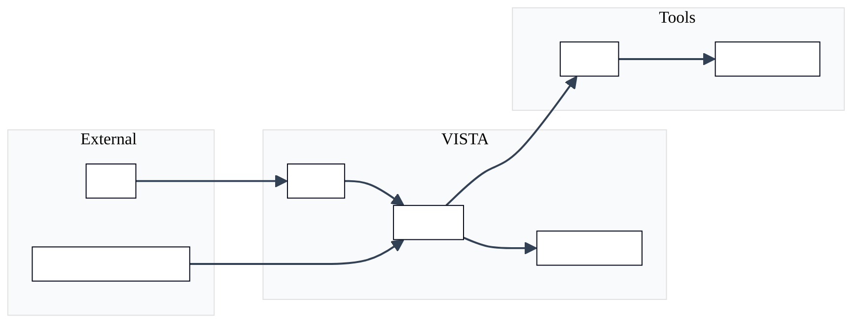
Figure 8 — diagram
Fig. 3.2 — Traceability from objectives to requirements.
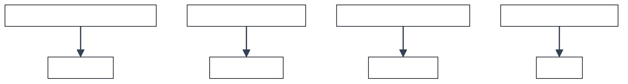
Figure 9 — diagram
Fig. 3.3 — Non-functional categories.
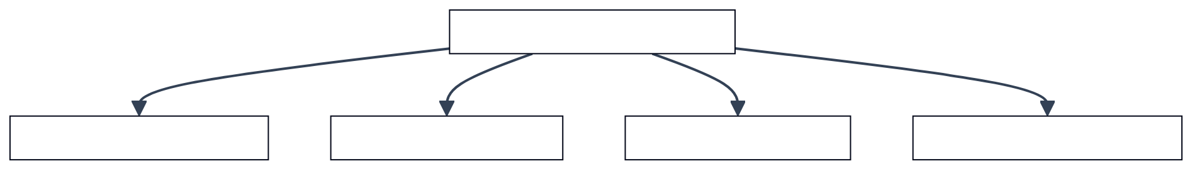
Figure 10 — diagram

CHAPTER IV

Chapter 4: Proposed solution (methodology, implementation)

4.1 Scientific method and reproducibility
Experiments are defined by a frozen run identifier, a pinned adapter checkpoint path, and logged flags in the machine-readable evaluation manifest. This chapter explains, at engineering level, how training data becomes a deployed pipeline.

4.2 Dataset and training configuration
The repository retains twenty thousand VERT-style pairs. Training uses the project defaults documented in Table 4.1.
Table 4.1 — Training hyperparameters (defaults).
Parameter | Value
Base model family | LLaMA 3.1 (8B)
Adaptation | QLoRA (rank / alpha 256 / 256)
Learning rate | 1e-4
Epochs | 3
Micro-batch × accumulation | 2 × 32 (effective 64)
Max sequence length | 4096

4.3 Core methodology narrative
The methodology interleaves learned generation with deterministic repair. The following figures summarize architecture, training flow, adaptation concept, runtime interactions, post-processing, wrapper construction, evaluation packaging, and deployment.
Fig. 4.1 — End-to-end methodology overview.
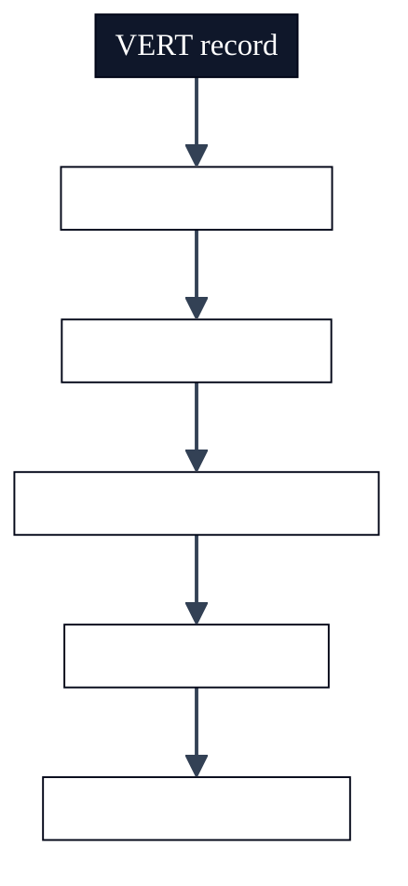
Figure 11 — diagram
Fig. 4.2 — Dataset and training flow.
Figure 12 — diagram
Fig. 4.3 — QLoRA adaptation (conceptual).
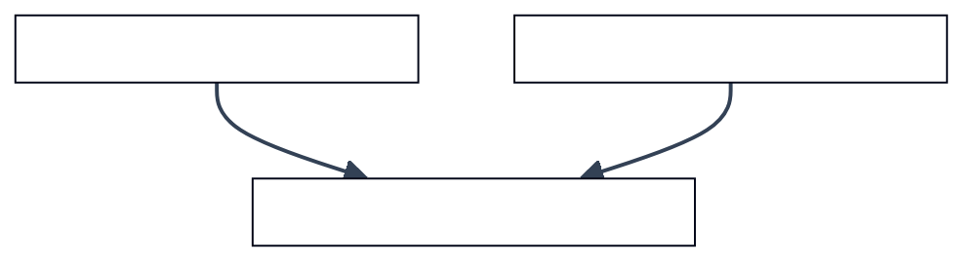
Figure 13 — diagram
Fig. 4.4 — Inference sequence (demonstration path).
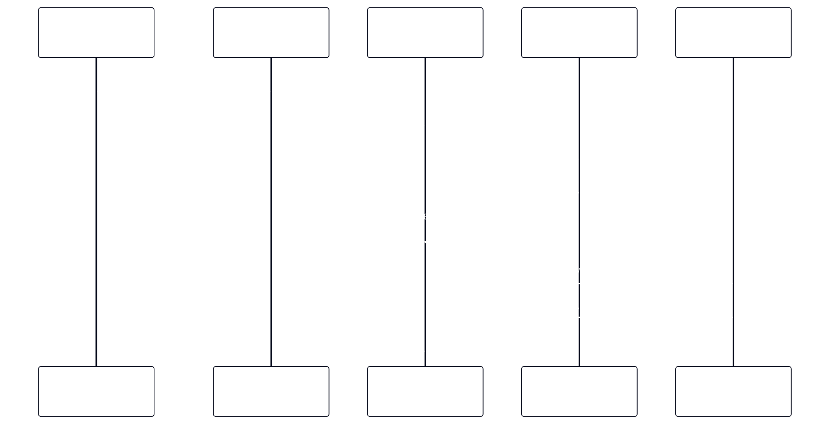
Figure 14 — diagram
Fig. 4.5 — Post-processing stages.
Figure 15 — diagram
Fig. 4.6 — Synchronous wrapper concept.
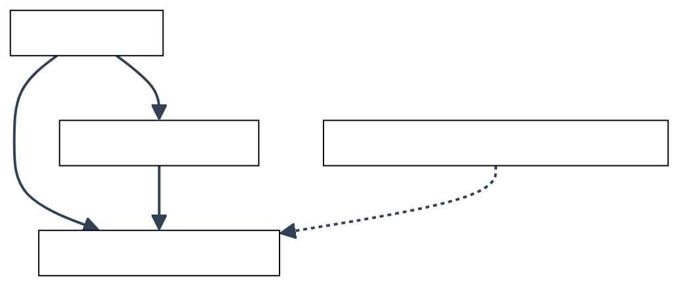
Figure 16 — diagram
Fig. 4.7 — Evaluation harness outputs.
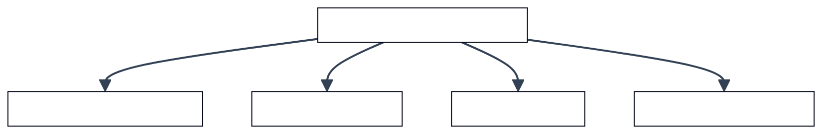
Figure 17 — diagram
Fig. 4.8 — Deployment layers.
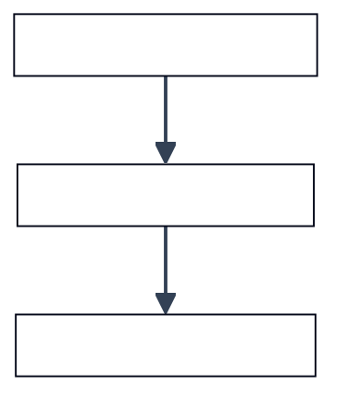
Figure 18 — diagram

4.4 Dataset curation and VERT record schema
This subsection discusses Dataset curation and VERT record schema as it relates to Chapter IV (methodology and implementation). Hardware verification research consistently shows that assertion quality—not raw engine throughput—often limits effective defect discovery. Automated generators must therefore be judged along multiple axes: syntactic acceptability, semantic alignment with designer intent on benchmark corpora, and stability under formal encodings that expose corner cases such as unknown bits and reset interactions. Review committees additionally expect clarity on dataset provenance, train–test overlap risks, and whether metrics are reported on a frozen slice or on a continuously moving checkpoint.
Within Dataset curation and VERT record schema, the VISTA project adopts a pragmatic stance aligned with open-source tooling: the VERT distribution supplies paired RTL and reference assertions, while SymbiYosys supplies bounded checks that are easy to reproduce in academic laboratories. This does not replace industrial sign-off flows; it provides a transparent yardstick for iterative model and pipeline improvements. Students extending this report should cite peer-reviewed and standard references in IEEE format, critique assumptions explicitly, and avoid overstating claims beyond the frozen evaluation slice reported in Chapter V.

4.5 Train/validation partitioning and leakage control
This subsection discusses Train/validation partitioning and leakage control as it relates to Chapter IV (methodology and implementation). Hardware verification research consistently shows that assertion quality—not raw engine throughput—often limits effective defect discovery. Automated generators must therefore be judged along multiple axes: syntactic acceptability, semantic alignment with designer intent on benchmark corpora, and stability under formal encodings that expose corner cases such as unknown bits and reset interactions. Review committees additionally expect clarity on dataset provenance, train–test overlap risks, and whether metrics are reported on a frozen slice or on a continuously moving checkpoint.
Within Train/validation partitioning and leakage control, the VISTA project adopts a pragmatic stance aligned with open-source tooling: the VERT distribution supplies paired RTL and reference assertions, while SymbiYosys supplies bounded checks that are easy to reproduce in academic laboratories. This does not replace industrial sign-off flows; it provides a transparent yardstick for iterative model and pipeline improvements. Students extending this report should cite peer-reviewed and standard references in IEEE format, critique assumptions explicitly, and avoid overstating claims beyond the frozen evaluation slice reported in Chapter V.

4.6 Prompt design and instruction–response alignment
This subsection discusses Prompt design and instruction–response alignment as it relates to Chapter IV (methodology and implementation). Hardware verification research consistently shows that assertion quality—not raw engine throughput—often limits effective defect discovery. Automated generators must therefore be judged along multiple axes: syntactic acceptability, semantic alignment with designer intent on benchmark corpora, and stability under formal encodings that expose corner cases such as unknown bits and reset interactions. Review committees additionally expect clarity on dataset provenance, train–test overlap risks, and whether metrics are reported on a frozen slice or on a continuously moving checkpoint.
Within Prompt design and instruction–response alignment, the VISTA project adopts a pragmatic stance aligned with open-source tooling: the VERT distribution supplies paired RTL and reference assertions, while SymbiYosys supplies bounded checks that are easy to reproduce in academic laboratories. This does not replace industrial sign-off flows; it provides a transparent yardstick for iterative model and pipeline improvements. Students extending this report should cite peer-reviewed and standard references in IEEE format, critique assumptions explicitly, and avoid overstating claims beyond the frozen evaluation slice reported in Chapter V.

4.7 Tokenization effects on hardware identifiers
This subsection discusses Tokenization effects on hardware identifiers as it relates to Chapter IV (methodology and implementation). Hardware verification research consistently shows that assertion quality—not raw engine throughput—often limits effective defect discovery. Automated generators must therefore be judged along multiple axes: syntactic acceptability, semantic alignment with designer intent on benchmark corpora, and stability under formal encodings that expose corner cases such as unknown bits and reset interactions. Review committees additionally expect clarity on dataset provenance, train–test overlap risks, and whether metrics are reported on a frozen slice or on a continuously moving checkpoint.
Within Tokenization effects on hardware identifiers, the VISTA project adopts a pragmatic stance aligned with open-source tooling: the VERT distribution supplies paired RTL and reference assertions, while SymbiYosys supplies bounded checks that are easy to reproduce in academic laboratories. This does not replace industrial sign-off flows; it provides a transparent yardstick for iterative model and pipeline improvements. Students extending this report should cite peer-reviewed and standard references in IEEE format, critique assumptions explicitly, and avoid overstating claims beyond the frozen evaluation slice reported in Chapter V.

4.8 LoRA adapter placement and trainable blocks
This subsection discusses LoRA adapter placement and trainable blocks as it relates to Chapter IV (methodology and implementation). Hardware verification research consistently shows that assertion quality—not raw engine throughput—often limits effective defect discovery. Automated generators must therefore be judged along multiple axes: syntactic acceptability, semantic alignment with designer intent on benchmark corpora, and stability under formal encodings that expose corner cases such as unknown bits and reset interactions. Review committees additionally expect clarity on dataset provenance, train–test overlap risks, and whether metrics are reported on a frozen slice or on a continuously moving checkpoint.
Within LoRA adapter placement and trainable blocks, the VISTA project adopts a pragmatic stance aligned with open-source tooling: the VERT distribution supplies paired RTL and reference assertions, while SymbiYosys supplies bounded checks that are easy to reproduce in academic laboratories. This does not replace industrial sign-off flows; it provides a transparent yardstick for iterative model and pipeline improvements. Students extending this report should cite peer-reviewed and standard references in IEEE format, critique assumptions explicitly, and avoid overstating claims beyond the frozen evaluation slice reported in Chapter V.

4.9 Optimizer choice and learning-rate schedules
This subsection discusses Optimizer choice and learning-rate schedules as it relates to Chapter IV (methodology and implementation). Hardware verification research consistently shows that assertion quality—not raw engine throughput—often limits effective defect discovery. Automated generators must therefore be judged along multiple axes: syntactic acceptability, semantic alignment with designer intent on benchmark corpora, and stability under formal encodings that expose corner cases such as unknown bits and reset interactions. Review committees additionally expect clarity on dataset provenance, train–test overlap risks, and whether metrics are reported on a frozen slice or on a continuously moving checkpoint.
Within Optimizer choice and learning-rate schedules, the VISTA project adopts a pragmatic stance aligned with open-source tooling: the VERT distribution supplies paired RTL and reference assertions, while SymbiYosys supplies bounded checks that are easy to reproduce in academic laboratories. This does not replace industrial sign-off flows; it provides a transparent yardstick for iterative model and pipeline improvements. Students extending this report should cite peer-reviewed and standard references in IEEE format, critique assumptions explicitly, and avoid overstating claims beyond the frozen evaluation slice reported in Chapter V.

4.10 Gradient accumulation and effective batch size
This subsection discusses Gradient accumulation and effective batch size as it relates to Chapter IV (methodology and implementation). Hardware verification research consistently shows that assertion quality—not raw engine throughput—often limits effective defect discovery. Automated generators must therefore be judged along multiple axes: syntactic acceptability, semantic alignment with designer intent on benchmark corpora, and stability under formal encodings that expose corner cases such as unknown bits and reset interactions. Review committees additionally expect clarity on dataset provenance, train–test overlap risks, and whether metrics are reported on a frozen slice or on a continuously moving checkpoint.
Within Gradient accumulation and effective batch size, the VISTA project adopts a pragmatic stance aligned with open-source tooling: the VERT distribution supplies paired RTL and reference assertions, while SymbiYosys supplies bounded checks that are easy to reproduce in academic laboratories. This does not replace industrial sign-off flows; it provides a transparent yardstick for iterative model and pipeline improvements. Students extending this report should cite peer-reviewed and standard references in IEEE format, critique assumptions explicitly, and avoid overstating claims beyond the frozen evaluation slice reported in Chapter V.

4.11 Mixed precision and numerical stability
This subsection discusses Mixed precision and numerical stability as it relates to Chapter IV (methodology and implementation). Hardware verification research consistently shows that assertion quality—not raw engine throughput—often limits effective defect discovery. Automated generators must therefore be judged along multiple axes: syntactic acceptability, semantic alignment with designer intent on benchmark corpora, and stability under formal encodings that expose corner cases such as unknown bits and reset interactions. Review committees additionally expect clarity on dataset provenance, train–test overlap risks, and whether metrics are reported on a frozen slice or on a continuously moving checkpoint.
Within Mixed precision and numerical stability, the VISTA project adopts a pragmatic stance aligned with open-source tooling: the VERT distribution supplies paired RTL and reference assertions, while SymbiYosys supplies bounded checks that are easy to reproduce in academic laboratories. This does not replace industrial sign-off flows; it provides a transparent yardstick for iterative model and pipeline improvements. Students extending this report should cite peer-reviewed and standard references in IEEE format, critique assumptions explicitly, and avoid overstating claims beyond the frozen evaluation slice reported in Chapter V.

4.12 Checkpoint selection and early stopping heuristics
This subsection discusses Checkpoint selection and early stopping heuristics as it relates to Chapter IV (methodology and implementation). Hardware verification research consistently shows that assertion quality—not raw engine throughput—often limits effective defect discovery. Automated generators must therefore be judged along multiple axes: syntactic acceptability, semantic alignment with designer intent on benchmark corpora, and stability under formal encodings that expose corner cases such as unknown bits and reset interactions. Review committees additionally expect clarity on dataset provenance, train–test overlap risks, and whether metrics are reported on a frozen slice or on a continuously moving checkpoint.
Within Checkpoint selection and early stopping heuristics, the VISTA project adopts a pragmatic stance aligned with open-source tooling: the VERT distribution supplies paired RTL and reference assertions, while SymbiYosys supplies bounded checks that are easy to reproduce in academic laboratories. This does not replace industrial sign-off flows; it provides a transparent yardstick for iterative model and pipeline improvements. Students extending this report should cite peer-reviewed and standard references in IEEE format, critique assumptions explicitly, and avoid overstating claims beyond the frozen evaluation slice reported in Chapter V.

4.13 Greedy decoding versus sampling for verification
This subsection discusses Greedy decoding versus sampling for verification as it relates to Chapter IV (methodology and implementation). Hardware verification research consistently shows that assertion quality—not raw engine throughput—often limits effective defect discovery. Automated generators must therefore be judged along multiple axes: syntactic acceptability, semantic alignment with designer intent on benchmark corpora, and stability under formal encodings that expose corner cases such as unknown bits and reset interactions. Review committees additionally expect clarity on dataset provenance, train–test overlap risks, and whether metrics are reported on a frozen slice or on a continuously moving checkpoint.
Within Greedy decoding versus sampling for verification, the VISTA project adopts a pragmatic stance aligned with open-source tooling: the VERT distribution supplies paired RTL and reference assertions, while SymbiYosys supplies bounded checks that are easy to reproduce in academic laboratories. This does not replace industrial sign-off flows; it provides a transparent yardstick for iterative model and pipeline improvements. Students extending this report should cite peer-reviewed and standard references in IEEE format, critique assumptions explicitly, and avoid overstating claims beyond the frozen evaluation slice reported in Chapter V.

4.14 Assertion extraction from verbose model outputs
This subsection discusses Assertion extraction from verbose model outputs as it relates to Chapter IV (methodology and implementation). Hardware verification research consistently shows that assertion quality—not raw engine throughput—often limits effective defect discovery. Automated generators must therefore be judged along multiple axes: syntactic acceptability, semantic alignment with designer intent on benchmark corpora, and stability under formal encodings that expose corner cases such as unknown bits and reset interactions. Review committees additionally expect clarity on dataset provenance, train–test overlap risks, and whether metrics are reported on a frozen slice or on a continuously moving checkpoint.
Within Assertion extraction from verbose model outputs, the VISTA project adopts a pragmatic stance aligned with open-source tooling: the VERT distribution supplies paired RTL and reference assertions, while SymbiYosys supplies bounded checks that are easy to reproduce in academic laboratories. This does not replace industrial sign-off flows; it provides a transparent yardstick for iterative model and pipeline improvements. Students extending this report should cite peer-reviewed and standard references in IEEE format, critique assumptions explicitly, and avoid overstating claims beyond the frozen evaluation slice reported in Chapter V.

4.15 Syntax sanitization for formal front ends
This subsection discusses Syntax sanitization for formal front ends as it relates to Chapter IV (methodology and implementation). Hardware verification research consistently shows that assertion quality—not raw engine throughput—often limits effective defect discovery. Automated generators must therefore be judged along multiple axes: syntactic acceptability, semantic alignment with designer intent on benchmark corpora, and stability under formal encodings that expose corner cases such as unknown bits and reset interactions. Review committees additionally expect clarity on dataset provenance, train–test overlap risks, and whether metrics are reported on a frozen slice or on a continuously moving checkpoint.
Within Syntax sanitization for formal front ends, the VISTA project adopts a pragmatic stance aligned with open-source tooling: the VERT distribution supplies paired RTL and reference assertions, while SymbiYosys supplies bounded checks that are easy to reproduce in academic laboratories. This does not replace industrial sign-off flows; it provides a transparent yardstick for iterative model and pipeline improvements. Students extending this report should cite peer-reviewed and standard references in IEEE format, critique assumptions explicitly, and avoid overstating claims beyond the frozen evaluation slice reported in Chapter V.

4.16 Temporal lowering and tool dialect mismatches
This subsection discusses Temporal lowering and tool dialect mismatches as it relates to Chapter IV (methodology and implementation). Hardware verification research consistently shows that assertion quality—not raw engine throughput—often limits effective defect discovery. Automated generators must therefore be judged along multiple axes: syntactic acceptability, semantic alignment with designer intent on benchmark corpora, and stability under formal encodings that expose corner cases such as unknown bits and reset interactions. Review committees additionally expect clarity on dataset provenance, train–test overlap risks, and whether metrics are reported on a frozen slice or on a continuously moving checkpoint.
Within Temporal lowering and tool dialect mismatches, the VISTA project adopts a pragmatic stance aligned with open-source tooling: the VERT distribution supplies paired RTL and reference assertions, while SymbiYosys supplies bounded checks that are easy to reproduce in academic laboratories. This does not replace industrial sign-off flows; it provides a transparent yardstick for iterative model and pipeline improvements. Students extending this report should cite peer-reviewed and standard references in IEEE format, critique assumptions explicitly, and avoid overstating claims beyond the frozen evaluation slice reported in Chapter V.

4.17 Greedy subset selection under parse constraints
This subsection discusses Greedy subset selection under parse constraints as it relates to Chapter IV (methodology and implementation). Hardware verification research consistently shows that assertion quality—not raw engine throughput—often limits effective defect discovery. Automated generators must therefore be judged along multiple axes: syntactic acceptability, semantic alignment with designer intent on benchmark corpora, and stability under formal encodings that expose corner cases such as unknown bits and reset interactions. Review committees additionally expect clarity on dataset provenance, train–test overlap risks, and whether metrics are reported on a frozen slice or on a continuously moving checkpoint.
Within Greedy subset selection under parse constraints, the VISTA project adopts a pragmatic stance aligned with open-source tooling: the VERT distribution supplies paired RTL and reference assertions, while SymbiYosys supplies bounded checks that are easy to reproduce in academic laboratories. This does not replace industrial sign-off flows; it provides a transparent yardstick for iterative model and pipeline improvements. Students extending this report should cite peer-reviewed and standard references in IEEE format, critique assumptions explicitly, and avoid overstating claims beyond the frozen evaluation slice reported in Chapter V.

4.18 Signal inference from RTL and assertion text
This subsection discusses Signal inference from RTL and assertion text as it relates to Chapter IV (methodology and implementation). Hardware verification research consistently shows that assertion quality—not raw engine throughput—often limits effective defect discovery. Automated generators must therefore be judged along multiple axes: syntactic acceptability, semantic alignment with designer intent on benchmark corpora, and stability under formal encodings that expose corner cases such as unknown bits and reset interactions. Review committees additionally expect clarity on dataset provenance, train–test overlap risks, and whether metrics are reported on a frozen slice or on a continuously moving checkpoint.
Within Signal inference from RTL and assertion text, the VISTA project adopts a pragmatic stance aligned with open-source tooling: the VERT distribution supplies paired RTL and reference assertions, while SymbiYosys supplies bounded checks that are easy to reproduce in academic laboratories. This does not replace industrial sign-off flows; it provides a transparent yardstick for iterative model and pipeline improvements. Students extending this report should cite peer-reviewed and standard references in IEEE format, critique assumptions explicitly, and avoid overstating claims beyond the frozen evaluation slice reported in Chapter V.

4.19 Keyword filtering and false signal candidates
This subsection discusses Keyword filtering and false signal candidates as it relates to Chapter IV (methodology and implementation). Hardware verification research consistently shows that assertion quality—not raw engine throughput—often limits effective defect discovery. Automated generators must therefore be judged along multiple axes: syntactic acceptability, semantic alignment with designer intent on benchmark corpora, and stability under formal encodings that expose corner cases such as unknown bits and reset interactions. Review committees additionally expect clarity on dataset provenance, train–test overlap risks, and whether metrics are reported on a frozen slice or on a continuously moving checkpoint.
Within Keyword filtering and false signal candidates, the VISTA project adopts a pragmatic stance aligned with open-source tooling: the VERT distribution supplies paired RTL and reference assertions, while SymbiYosys supplies bounded checks that are easy to reproduce in academic laboratories. This does not replace industrial sign-off flows; it provides a transparent yardstick for iterative model and pipeline improvements. Students extending this report should cite peer-reviewed and standard references in IEEE format, critique assumptions explicitly, and avoid overstating claims beyond the frozen evaluation slice reported in Chapter V.

4.20 Synchronous harness construction and two-phase updates
This subsection discusses Synchronous harness construction and two-phase updates as it relates to Chapter IV (methodology and implementation). Hardware verification research consistently shows that assertion quality—not raw engine throughput—often limits effective defect discovery. Automated generators must therefore be judged along multiple axes: syntactic acceptability, semantic alignment with designer intent on benchmark corpora, and stability under formal encodings that expose corner cases such as unknown bits and reset interactions. Review committees additionally expect clarity on dataset provenance, train–test overlap risks, and whether metrics are reported on a frozen slice or on a continuously moving checkpoint.
Within Synchronous harness construction and two-phase updates, the VISTA project adopts a pragmatic stance aligned with open-source tooling: the VERT distribution supplies paired RTL and reference assertions, while SymbiYosys supplies bounded checks that are easy to reproduce in academic laboratories. This does not replace industrial sign-off flows; it provides a transparent yardstick for iterative model and pipeline improvements. Students extending this report should cite peer-reviewed and standard references in IEEE format, critique assumptions explicitly, and avoid overstating claims beyond the frozen evaluation slice reported in Chapter V.

4.21 Combinational harness construction with always_comb semantics
This subsection discusses Combinational harness construction with always_comb semantics as it relates to Chapter IV (methodology and implementation). Hardware verification research consistently shows that assertion quality—not raw engine throughput—often limits effective defect discovery. Automated generators must therefore be judged along multiple axes: syntactic acceptability, semantic alignment with designer intent on benchmark corpora, and stability under formal encodings that expose corner cases such as unknown bits and reset interactions. Review committees additionally expect clarity on dataset provenance, train–test overlap risks, and whether metrics are reported on a frozen slice or on a continuously moving checkpoint.
Within Combinational harness construction with always_comb semantics, the VISTA project adopts a pragmatic stance aligned with open-source tooling: the VERT distribution supplies paired RTL and reference assertions, while SymbiYosys supplies bounded checks that are easy to reproduce in academic laboratories. This does not replace industrial sign-off flows; it provides a transparent yardstick for iterative model and pipeline improvements. Students extending this report should cite peer-reviewed and standard references in IEEE format, critique assumptions explicitly, and avoid overstating claims beyond the frozen evaluation slice reported in Chapter V.

4.22 First-cycle gating and vacuity mitigation
This subsection discusses First-cycle gating and vacuity mitigation as it relates to Chapter IV (methodology and implementation). Hardware verification research consistently shows that assertion quality—not raw engine throughput—often limits effective defect discovery. Automated generators must therefore be judged along multiple axes: syntactic acceptability, semantic alignment with designer intent on benchmark corpora, and stability under formal encodings that expose corner cases such as unknown bits and reset interactions. Review committees additionally expect clarity on dataset provenance, train–test overlap risks, and whether metrics are reported on a frozen slice or on a continuously moving checkpoint.
Within First-cycle gating and vacuity mitigation, the VISTA project adopts a pragmatic stance aligned with open-source tooling: the VERT distribution supplies paired RTL and reference assertions, while SymbiYosys supplies bounded checks that are easy to reproduce in academic laboratories. This does not replace industrial sign-off flows; it provides a transparent yardstick for iterative model and pipeline improvements. Students extending this report should cite peer-reviewed and standard references in IEEE format, critique assumptions explicitly, and avoid overstating claims beyond the frozen evaluation slice reported in Chapter V.

4.23 SymbiYosys engine configuration and proof depth
This subsection discusses SymbiYosys engine configuration and proof depth as it relates to Chapter IV (methodology and implementation). Hardware verification research consistently shows that assertion quality—not raw engine throughput—often limits effective defect discovery. Automated generators must therefore be judged along multiple axes: syntactic acceptability, semantic alignment with designer intent on benchmark corpora, and stability under formal encodings that expose corner cases such as unknown bits and reset interactions. Review committees additionally expect clarity on dataset provenance, train–test overlap risks, and whether metrics are reported on a frozen slice or on a continuously moving checkpoint.
Within SymbiYosys engine configuration and proof depth, the VISTA project adopts a pragmatic stance aligned with open-source tooling: the VERT distribution supplies paired RTL and reference assertions, while SymbiYosys supplies bounded checks that are easy to reproduce in academic laboratories. This does not replace industrial sign-off flows; it provides a transparent yardstick for iterative model and pipeline improvements. Students extending this report should cite peer-reviewed and standard references in IEEE format, critique assumptions explicitly, and avoid overstating claims beyond the frozen evaluation slice reported in Chapter V.

4.24 Per-case artifacts and regression packaging
This subsection discusses Per-case artifacts and regression packaging as it relates to Chapter IV (methodology and implementation). Hardware verification research consistently shows that assertion quality—not raw engine throughput—often limits effective defect discovery. Automated generators must therefore be judged along multiple axes: syntactic acceptability, semantic alignment with designer intent on benchmark corpora, and stability under formal encodings that expose corner cases such as unknown bits and reset interactions. Review committees additionally expect clarity on dataset provenance, train–test overlap risks, and whether metrics are reported on a frozen slice or on a continuously moving checkpoint.
Within Per-case artifacts and regression packaging, the VISTA project adopts a pragmatic stance aligned with open-source tooling: the VERT distribution supplies paired RTL and reference assertions, while SymbiYosys supplies bounded checks that are easy to reproduce in academic laboratories. This does not replace industrial sign-off flows; it provides a transparent yardstick for iterative model and pipeline improvements. Students extending this report should cite peer-reviewed and standard references in IEEE format, critique assumptions explicitly, and avoid overstating claims beyond the frozen evaluation slice reported in Chapter V.

4.25 Web demonstration architecture and separation of concerns
This subsection discusses Web demonstration architecture and separation of concerns as it relates to Chapter IV (methodology and implementation). Hardware verification research consistently shows that assertion quality—not raw engine throughput—often limits effective defect discovery. Automated generators must therefore be judged along multiple axes: syntactic acceptability, semantic alignment with designer intent on benchmark corpora, and stability under formal encodings that expose corner cases such as unknown bits and reset interactions. Review committees additionally expect clarity on dataset provenance, train–test overlap risks, and whether metrics are reported on a frozen slice or on a continuously moving checkpoint.
Within Web demonstration architecture and separation of concerns, the VISTA project adopts a pragmatic stance aligned with open-source tooling: the VERT distribution supplies paired RTL and reference assertions, while SymbiYosys supplies bounded checks that are easy to reproduce in academic laboratories. This does not replace industrial sign-off flows; it provides a transparent yardstick for iterative model and pipeline improvements. Students extending this report should cite peer-reviewed and standard references in IEEE format, critique assumptions explicitly, and avoid overstating claims beyond the frozen evaluation slice reported in Chapter V.

4.26 Operational security for proprietary RTL
This subsection discusses Operational security for proprietary RTL as it relates to Chapter IV (methodology and implementation). Hardware verification research consistently shows that assertion quality—not raw engine throughput—often limits effective defect discovery. Automated generators must therefore be judged along multiple axes: syntactic acceptability, semantic alignment with designer intent on benchmark corpora, and stability under formal encodings that expose corner cases such as unknown bits and reset interactions. Review committees additionally expect clarity on dataset provenance, train–test overlap risks, and whether metrics are reported on a frozen slice or on a continuously moving checkpoint.
Within Operational security for proprietary RTL, the VISTA project adopts a pragmatic stance aligned with open-source tooling: the VERT distribution supplies paired RTL and reference assertions, while SymbiYosys supplies bounded checks that are easy to reproduce in academic laboratories. This does not replace industrial sign-off flows; it provides a transparent yardstick for iterative model and pipeline improvements. Students extending this report should cite peer-reviewed and standard references in IEEE format, critique assumptions explicitly, and avoid overstating claims beyond the frozen evaluation slice reported in Chapter V.

Chapter IV supplement — M1: Logging and experiment tracking practices
This subsection discusses Logging and experiment tracking practices as it relates to Chapter IV engineering practice. Hardware verification research consistently shows that assertion quality—not raw engine throughput—often limits effective defect discovery. Automated generators must therefore be judged along multiple axes: syntactic acceptability, semantic alignment with designer intent on benchmark corpora, and stability under formal encodings that expose corner cases such as unknown bits and reset interactions. Review committees additionally expect clarity on dataset provenance, train–test overlap risks, and whether metrics are reported on a frozen slice or on a continuously moving checkpoint.
Within Logging and experiment tracking practices, the VISTA project adopts a pragmatic stance aligned with open-source tooling: the VERT distribution supplies paired RTL and reference assertions, while SymbiYosys supplies bounded checks that are easy to reproduce in academic laboratories. This does not replace industrial sign-off flows; it provides a transparent yardstick for iterative model and pipeline improvements. Students extending this report should cite peer-reviewed and standard references in IEEE format, critique assumptions explicitly, and avoid overstating claims beyond the frozen evaluation slice reported in Chapter V.

Chapter IV supplement — M2: Version pinning for PyTorch and CUDA drivers
This subsection discusses Version pinning for PyTorch and CUDA drivers as it relates to Chapter IV engineering practice. Hardware verification research consistently shows that assertion quality—not raw engine throughput—often limits effective defect discovery. Automated generators must therefore be judged along multiple axes: syntactic acceptability, semantic alignment with designer intent on benchmark corpora, and stability under formal encodings that expose corner cases such as unknown bits and reset interactions. Review committees additionally expect clarity on dataset provenance, train–test overlap risks, and whether metrics are reported on a frozen slice or on a continuously moving checkpoint.
Within Version pinning for PyTorch and CUDA drivers, the VISTA project adopts a pragmatic stance aligned with open-source tooling: the VERT distribution supplies paired RTL and reference assertions, while SymbiYosys supplies bounded checks that are easy to reproduce in academic laboratories. This does not replace industrial sign-off flows; it provides a transparent yardstick for iterative model and pipeline improvements. Students extending this report should cite peer-reviewed and standard references in IEEE format, critique assumptions explicitly, and avoid overstating claims beyond the frozen evaluation slice reported in Chapter V.

Chapter IV supplement — M3: Timeout policies for long-running formal jobs
This subsection discusses Timeout policies for long-running formal jobs as it relates to Chapter IV engineering practice. Hardware verification research consistently shows that assertion quality—not raw engine throughput—often limits effective defect discovery. Automated generators must therefore be judged along multiple axes: syntactic acceptability, semantic alignment with designer intent on benchmark corpora, and stability under formal encodings that expose corner cases such as unknown bits and reset interactions. Review committees additionally expect clarity on dataset provenance, train–test overlap risks, and whether metrics are reported on a frozen slice or on a continuously moving checkpoint.
Within Timeout policies for long-running formal jobs, the VISTA project adopts a pragmatic stance aligned with open-source tooling: the VERT distribution supplies paired RTL and reference assertions, while SymbiYosys supplies bounded checks that are easy to reproduce in academic laboratories. This does not replace industrial sign-off flows; it provides a transparent yardstick for iterative model and pipeline improvements. Students extending this report should cite peer-reviewed and standard references in IEEE format, critique assumptions explicitly, and avoid overstating claims beyond the frozen evaluation slice reported in Chapter V.

Chapter IV supplement — M4: Unit tests for parsing and extraction
This subsection discusses Unit tests for parsing and extraction as it relates to Chapter IV engineering practice. Hardware verification research consistently shows that assertion quality—not raw engine throughput—often limits effective defect discovery. Automated generators must therefore be judged along multiple axes: syntactic acceptability, semantic alignment with designer intent on benchmark corpora, and stability under formal encodings that expose corner cases such as unknown bits and reset interactions. Review committees additionally expect clarity on dataset provenance, train–test overlap risks, and whether metrics are reported on a frozen slice or on a continuously moving checkpoint.
Within Unit tests for parsing and extraction, the VISTA project adopts a pragmatic stance aligned with open-source tooling: the VERT distribution supplies paired RTL and reference assertions, while SymbiYosys supplies bounded checks that are easy to reproduce in academic laboratories. This does not replace industrial sign-off flows; it provides a transparent yardstick for iterative model and pipeline improvements. Students extending this report should cite peer-reviewed and standard references in IEEE format, critique assumptions explicitly, and avoid overstating claims beyond the frozen evaluation slice reported in Chapter V.

Chapter IV supplement — M5: Continuous integration for evaluation scripts
This subsection discusses Continuous integration for evaluation scripts as it relates to Chapter IV engineering practice. Hardware verification research consistently shows that assertion quality—not raw engine throughput—often limits effective defect discovery. Automated generators must therefore be judged along multiple axes: syntactic acceptability, semantic alignment with designer intent on benchmark corpora, and stability under formal encodings that expose corner cases such as unknown bits and reset interactions. Review committees additionally expect clarity on dataset provenance, train–test overlap risks, and whether metrics are reported on a frozen slice or on a continuously moving checkpoint.
Within Continuous integration for evaluation scripts, the VISTA project adopts a pragmatic stance aligned with open-source tooling: the VERT distribution supplies paired RTL and reference assertions, while SymbiYosys supplies bounded checks that are easy to reproduce in academic laboratories. This does not replace industrial sign-off flows; it provides a transparent yardstick for iterative model and pipeline improvements. Students extending this report should cite peer-reviewed and standard references in IEEE format, critique assumptions explicitly, and avoid overstating claims beyond the frozen evaluation slice reported in Chapter V.

Chapter IV supplement — M6: Checksum verification for datasets
This subsection discusses Checksum verification for datasets as it relates to Chapter IV engineering practice. Hardware verification research consistently shows that assertion quality—not raw engine throughput—often limits effective defect discovery. Automated generators must therefore be judged along multiple axes: syntactic acceptability, semantic alignment with designer intent on benchmark corpora, and stability under formal encodings that expose corner cases such as unknown bits and reset interactions. Review committees additionally expect clarity on dataset provenance, train–test overlap risks, and whether metrics are reported on a frozen slice or on a continuously moving checkpoint.
Within Checksum verification for datasets, the VISTA project adopts a pragmatic stance aligned with open-source tooling: the VERT distribution supplies paired RTL and reference assertions, while SymbiYosys supplies bounded checks that are easy to reproduce in academic laboratories. This does not replace industrial sign-off flows; it provides a transparent yardstick for iterative model and pipeline improvements. Students extending this report should cite peer-reviewed and standard references in IEEE format, critique assumptions explicitly, and avoid overstating claims beyond the frozen evaluation slice reported in Chapter V.

CHAPTER V

Chapter 5: Results and discussion

5.1 Metrics and equation for gold Jaccard
Let token sets for generated assertion text A and reference B be T(A) and T(B). The gold Jaccard similarity used in the evaluation manifest is
$$J_{gold}(A,B)=\frac{|T(A)∩T(B)|}{|T(A)∪T(B)|}.$$
In the final Word document, number this display as (1.1) per institute format and define all symbols immediately above or below.

5.2 Aggregate results
Table 5.1 — Aggregate metrics (frozen run).
Metric | Value
Samples | 100
Yosys syntax success | 100 / 100
SymbiYosys pass | 99 / 100
SymbiYosys fail | 1
Mean gold Jaccard | 0.991364
Greedy dropped clauses (sum) | 14
Attempted / converted clauses | 472 / 472
Table 5.2 — Gold Jaccard buckets.
Bucket | Count
0.900 – 0.949 | 9
0.950 – 0.998 | 1
≥ 0.999 | 89
< 0.900 | 1

5.3 Discussion of formal failure (sample 82)
Index 82 fails SymbiYosys while maintaining gold Jaccard 1.0. The RTL includes a case selector with X bits. Formal outcomes therefore depend on encoding and assumptions, not only string equality to the VERT reference.
Fig. 5.1 — Evaluation workflow.
Figure 19 — diagram
Fig. 5.2 — Aggregate outcomes (n = 100).
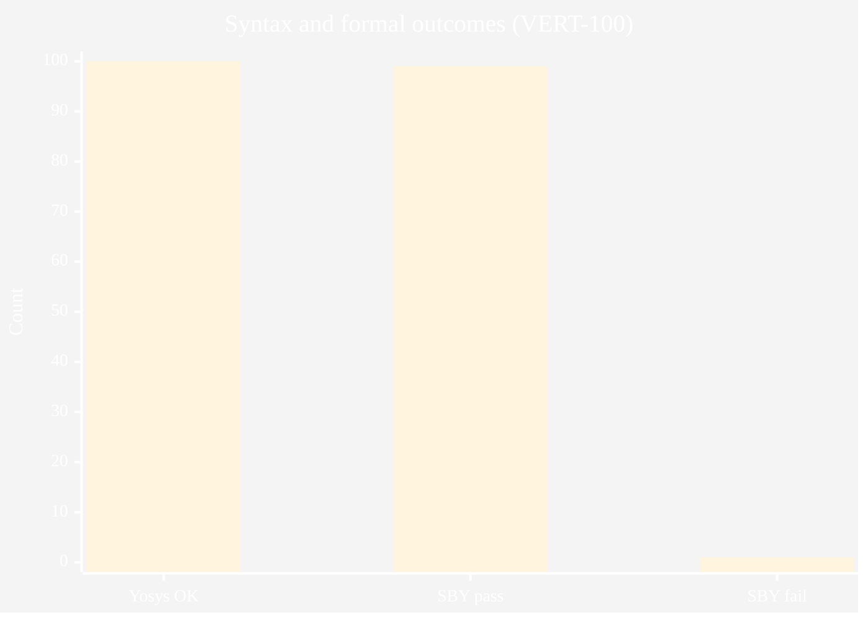
Figure 20 — diagram
Fig. 5.3 — Gold Jaccard distribution.
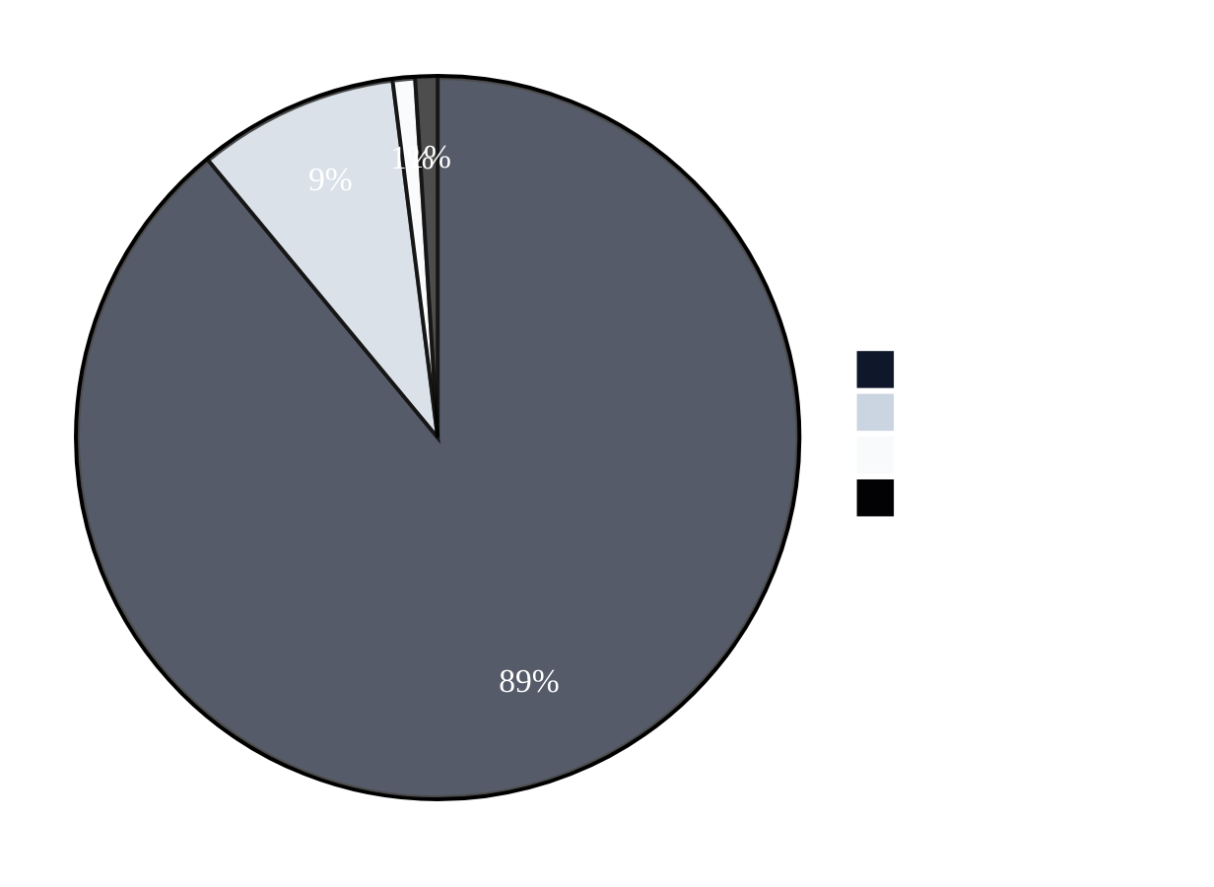
Figure 21 — diagram
Fig. 5.4 — Interpreting outcomes (conceptual).
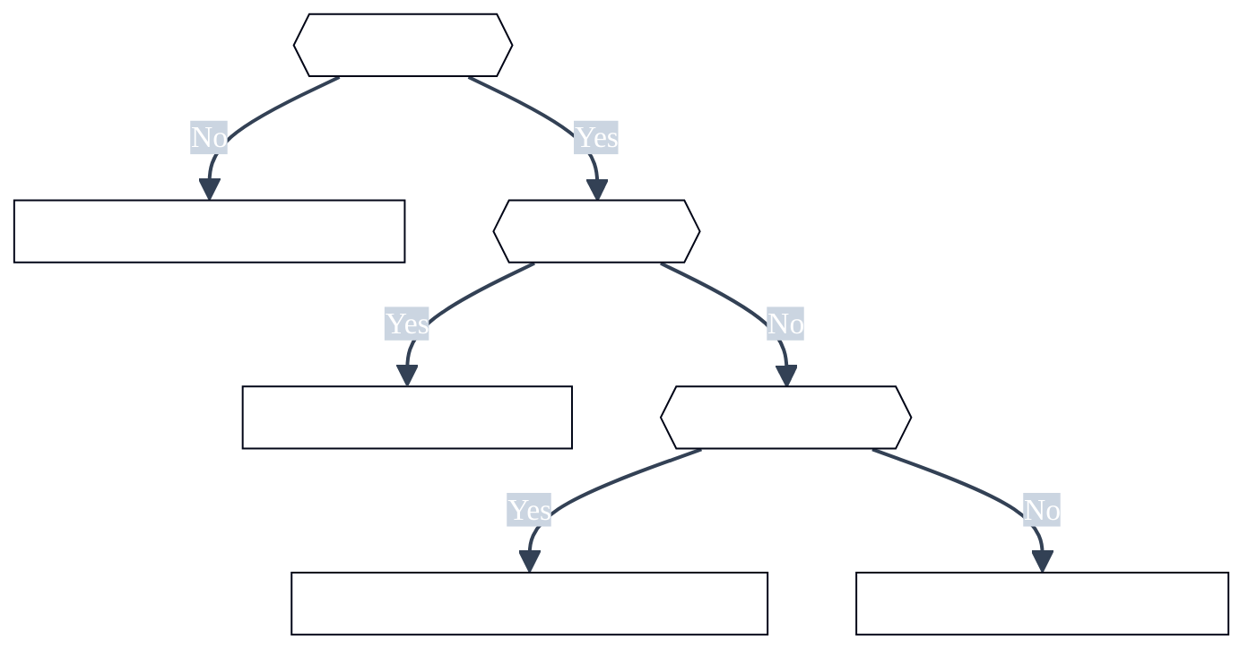
Figure 22 — diagram

5.6 Reporting syntax success versus semantic proof
This subsection discusses Reporting syntax success versus semantic proof as it relates to Chapter V (results and discussion). Hardware verification research consistently shows that assertion quality—not raw engine throughput—often limits effective defect discovery. Automated generators must therefore be judged along multiple axes: syntactic acceptability, semantic alignment with designer intent on benchmark corpora, and stability under formal encodings that expose corner cases such as unknown bits and reset interactions. Review committees additionally expect clarity on dataset provenance, train–test overlap risks, and whether metrics are reported on a frozen slice or on a continuously moving checkpoint.
Within Reporting syntax success versus semantic proof, the VISTA project adopts a pragmatic stance aligned with open-source tooling: the VERT distribution supplies paired RTL and reference assertions, while SymbiYosys supplies bounded checks that are easy to reproduce in academic laboratories. This does not replace industrial sign-off flows; it provides a transparent yardstick for iterative model and pipeline improvements. Students extending this report should cite peer-reviewed and standard references in IEEE format, critique assumptions explicitly, and avoid overstating claims beyond the frozen evaluation slice reported in Chapter V.

5.7 Interpreting SymbiYosys pass and fail verdicts
This subsection discusses Interpreting SymbiYosys pass and fail verdicts as it relates to Chapter V (results and discussion). Hardware verification research consistently shows that assertion quality—not raw engine throughput—often limits effective defect discovery. Automated generators must therefore be judged along multiple axes: syntactic acceptability, semantic alignment with designer intent on benchmark corpora, and stability under formal encodings that expose corner cases such as unknown bits and reset interactions. Review committees additionally expect clarity on dataset provenance, train–test overlap risks, and whether metrics are reported on a frozen slice or on a continuously moving checkpoint.
Within Interpreting SymbiYosys pass and fail verdicts, the VISTA project adopts a pragmatic stance aligned with open-source tooling: the VERT distribution supplies paired RTL and reference assertions, while SymbiYosys supplies bounded checks that are easy to reproduce in academic laboratories. This does not replace industrial sign-off flows; it provides a transparent yardstick for iterative model and pipeline improvements. Students extending this report should cite peer-reviewed and standard references in IEEE format, critique assumptions explicitly, and avoid overstating claims beyond the frozen evaluation slice reported in Chapter V.

5.8 Gold Jaccard as a lexical alignment metric
This subsection discusses Gold Jaccard as a lexical alignment metric as it relates to Chapter V (results and discussion). Hardware verification research consistently shows that assertion quality—not raw engine throughput—often limits effective defect discovery. Automated generators must therefore be judged along multiple axes: syntactic acceptability, semantic alignment with designer intent on benchmark corpora, and stability under formal encodings that expose corner cases such as unknown bits and reset interactions. Review committees additionally expect clarity on dataset provenance, train–test overlap risks, and whether metrics are reported on a frozen slice or on a continuously moving checkpoint.
Within Gold Jaccard as a lexical alignment metric, the VISTA project adopts a pragmatic stance aligned with open-source tooling: the VERT distribution supplies paired RTL and reference assertions, while SymbiYosys supplies bounded checks that are easy to reproduce in academic laboratories. This does not replace industrial sign-off flows; it provides a transparent yardstick for iterative model and pipeline improvements. Students extending this report should cite peer-reviewed and standard references in IEEE format, critique assumptions explicitly, and avoid overstating claims beyond the frozen evaluation slice reported in Chapter V.

5.9 Correlation between Jaccard and formal pass rate
This subsection discusses Correlation between Jaccard and formal pass rate as it relates to Chapter V (results and discussion). Hardware verification research consistently shows that assertion quality—not raw engine throughput—often limits effective defect discovery. Automated generators must therefore be judged along multiple axes: syntactic acceptability, semantic alignment with designer intent on benchmark corpora, and stability under formal encodings that expose corner cases such as unknown bits and reset interactions. Review committees additionally expect clarity on dataset provenance, train–test overlap risks, and whether metrics are reported on a frozen slice or on a continuously moving checkpoint.
Within Correlation between Jaccard and formal pass rate, the VISTA project adopts a pragmatic stance aligned with open-source tooling: the VERT distribution supplies paired RTL and reference assertions, while SymbiYosys supplies bounded checks that are easy to reproduce in academic laboratories. This does not replace industrial sign-off flows; it provides a transparent yardstick for iterative model and pipeline improvements. Students extending this report should cite peer-reviewed and standard references in IEEE format, critique assumptions explicitly, and avoid overstating claims beyond the frozen evaluation slice reported in Chapter V.

5.10 Outlier analysis for low-Jaccard samples
This subsection discusses Outlier analysis for low-Jaccard samples as it relates to Chapter V (results and discussion). Hardware verification research consistently shows that assertion quality—not raw engine throughput—often limits effective defect discovery. Automated generators must therefore be judged along multiple axes: syntactic acceptability, semantic alignment with designer intent on benchmark corpora, and stability under formal encodings that expose corner cases such as unknown bits and reset interactions. Review committees additionally expect clarity on dataset provenance, train–test overlap risks, and whether metrics are reported on a frozen slice or on a continuously moving checkpoint.
Within Outlier analysis for low-Jaccard samples, the VISTA project adopts a pragmatic stance aligned with open-source tooling: the VERT distribution supplies paired RTL and reference assertions, while SymbiYosys supplies bounded checks that are easy to reproduce in academic laboratories. This does not replace industrial sign-off flows; it provides a transparent yardstick for iterative model and pipeline improvements. Students extending this report should cite peer-reviewed and standard references in IEEE format, critique assumptions explicitly, and avoid overstating claims beyond the frozen evaluation slice reported in Chapter V.

5.11 Formal failure with high Jaccard: case semantics
This subsection discusses Formal failure with high Jaccard: case semantics as it relates to Chapter V (results and discussion). Hardware verification research consistently shows that assertion quality—not raw engine throughput—often limits effective defect discovery. Automated generators must therefore be judged along multiple axes: syntactic acceptability, semantic alignment with designer intent on benchmark corpora, and stability under formal encodings that expose corner cases such as unknown bits and reset interactions. Review committees additionally expect clarity on dataset provenance, train–test overlap risks, and whether metrics are reported on a frozen slice or on a continuously moving checkpoint.
Within Formal failure with high Jaccard: case semantics, the VISTA project adopts a pragmatic stance aligned with open-source tooling: the VERT distribution supplies paired RTL and reference assertions, while SymbiYosys supplies bounded checks that are easy to reproduce in academic laboratories. This does not replace industrial sign-off flows; it provides a transparent yardstick for iterative model and pipeline improvements. Students extending this report should cite peer-reviewed and standard references in IEEE format, critique assumptions explicitly, and avoid overstating claims beyond the frozen evaluation slice reported in Chapter V.

5.12 Effect of greedy assertion filtering on yield
This subsection discusses Effect of greedy assertion filtering on yield as it relates to Chapter V (results and discussion). Hardware verification research consistently shows that assertion quality—not raw engine throughput—often limits effective defect discovery. Automated generators must therefore be judged along multiple axes: syntactic acceptability, semantic alignment with designer intent on benchmark corpora, and stability under formal encodings that expose corner cases such as unknown bits and reset interactions. Review committees additionally expect clarity on dataset provenance, train–test overlap risks, and whether metrics are reported on a frozen slice or on a continuously moving checkpoint.
Within Effect of greedy assertion filtering on yield, the VISTA project adopts a pragmatic stance aligned with open-source tooling: the VERT distribution supplies paired RTL and reference assertions, while SymbiYosys supplies bounded checks that are easy to reproduce in academic laboratories. This does not replace industrial sign-off flows; it provides a transparent yardstick for iterative model and pipeline improvements. Students extending this report should cite peer-reviewed and standard references in IEEE format, critique assumptions explicitly, and avoid overstating claims beyond the frozen evaluation slice reported in Chapter V.

5.13 Clause-level counts and aggregation in the manifest
This subsection discusses Clause-level counts and aggregation in the manifest as it relates to Chapter V (results and discussion). Hardware verification research consistently shows that assertion quality—not raw engine throughput—often limits effective defect discovery. Automated generators must therefore be judged along multiple axes: syntactic acceptability, semantic alignment with designer intent on benchmark corpora, and stability under formal encodings that expose corner cases such as unknown bits and reset interactions. Review committees additionally expect clarity on dataset provenance, train–test overlap risks, and whether metrics are reported on a frozen slice or on a continuously moving checkpoint.
Within Clause-level counts and aggregation in the manifest, the VISTA project adopts a pragmatic stance aligned with open-source tooling: the VERT distribution supplies paired RTL and reference assertions, while SymbiYosys supplies bounded checks that are easy to reproduce in academic laboratories. This does not replace industrial sign-off flows; it provides a transparent yardstick for iterative model and pipeline improvements. Students extending this report should cite peer-reviewed and standard references in IEEE format, critique assumptions explicitly, and avoid overstating claims beyond the frozen evaluation slice reported in Chapter V.

5.14 Bounded depth and completeness caveats
This subsection discusses Bounded depth and completeness caveats as it relates to Chapter V (results and discussion). Hardware verification research consistently shows that assertion quality—not raw engine throughput—often limits effective defect discovery. Automated generators must therefore be judged along multiple axes: syntactic acceptability, semantic alignment with designer intent on benchmark corpora, and stability under formal encodings that expose corner cases such as unknown bits and reset interactions. Review committees additionally expect clarity on dataset provenance, train–test overlap risks, and whether metrics are reported on a frozen slice or on a continuously moving checkpoint.
Within Bounded depth and completeness caveats, the VISTA project adopts a pragmatic stance aligned with open-source tooling: the VERT distribution supplies paired RTL and reference assertions, while SymbiYosys supplies bounded checks that are easy to reproduce in academic laboratories. This does not replace industrial sign-off flows; it provides a transparent yardstick for iterative model and pipeline improvements. Students extending this report should cite peer-reviewed and standard references in IEEE format, critique assumptions explicitly, and avoid overstating claims beyond the frozen evaluation slice reported in Chapter V.

5.15 Threats to internal validity of the evaluation slice
This subsection discusses Threats to internal validity of the evaluation slice as it relates to Chapter V (results and discussion). Hardware verification research consistently shows that assertion quality—not raw engine throughput—often limits effective defect discovery. Automated generators must therefore be judged along multiple axes: syntactic acceptability, semantic alignment with designer intent on benchmark corpora, and stability under formal encodings that expose corner cases such as unknown bits and reset interactions. Review committees additionally expect clarity on dataset provenance, train–test overlap risks, and whether metrics are reported on a frozen slice or on a continuously moving checkpoint.
Within Threats to internal validity of the evaluation slice, the VISTA project adopts a pragmatic stance aligned with open-source tooling: the VERT distribution supplies paired RTL and reference assertions, while SymbiYosys supplies bounded checks that are easy to reproduce in academic laboratories. This does not replace industrial sign-off flows; it provides a transparent yardstick for iterative model and pipeline improvements. Students extending this report should cite peer-reviewed and standard references in IEEE format, critique assumptions explicitly, and avoid overstating claims beyond the frozen evaluation slice reported in Chapter V.

5.16 Threats to external validity beyond VERT
This subsection discusses Threats to external validity beyond VERT as it relates to Chapter V (results and discussion). Hardware verification research consistently shows that assertion quality—not raw engine throughput—often limits effective defect discovery. Automated generators must therefore be judged along multiple axes: syntactic acceptability, semantic alignment with designer intent on benchmark corpora, and stability under formal encodings that expose corner cases such as unknown bits and reset interactions. Review committees additionally expect clarity on dataset provenance, train–test overlap risks, and whether metrics are reported on a frozen slice or on a continuously moving checkpoint.
Within Threats to external validity beyond VERT, the VISTA project adopts a pragmatic stance aligned with open-source tooling: the VERT distribution supplies paired RTL and reference assertions, while SymbiYosys supplies bounded checks that are easy to reproduce in academic laboratories. This does not replace industrial sign-off flows; it provides a transparent yardstick for iterative model and pipeline improvements. Students extending this report should cite peer-reviewed and standard references in IEEE format, critique assumptions explicitly, and avoid overstating claims beyond the frozen evaluation slice reported in Chapter V.

5.17 Comparison to AssertionBench-style claims
This subsection discusses Comparison to AssertionBench-style claims as it relates to Chapter V (results and discussion). Hardware verification research consistently shows that assertion quality—not raw engine throughput—often limits effective defect discovery. Automated generators must therefore be judged along multiple axes: syntactic acceptability, semantic alignment with designer intent on benchmark corpora, and stability under formal encodings that expose corner cases such as unknown bits and reset interactions. Review committees additionally expect clarity on dataset provenance, train–test overlap risks, and whether metrics are reported on a frozen slice or on a continuously moving checkpoint.
Within Comparison to AssertionBench-style claims, the VISTA project adopts a pragmatic stance aligned with open-source tooling: the VERT distribution supplies paired RTL and reference assertions, while SymbiYosys supplies bounded checks that are easy to reproduce in academic laboratories. This does not replace industrial sign-off flows; it provides a transparent yardstick for iterative model and pipeline improvements. Students extending this report should cite peer-reviewed and standard references in IEEE format, critique assumptions explicitly, and avoid overstating claims beyond the frozen evaluation slice reported in Chapter V.

5.18 Industrial metrics: review effort and time saved
This subsection discusses Industrial metrics: review effort and time saved as it relates to Chapter V (results and discussion). Hardware verification research consistently shows that assertion quality—not raw engine throughput—often limits effective defect discovery. Automated generators must therefore be judged along multiple axes: syntactic acceptability, semantic alignment with designer intent on benchmark corpora, and stability under formal encodings that expose corner cases such as unknown bits and reset interactions. Review committees additionally expect clarity on dataset provenance, train–test overlap risks, and whether metrics are reported on a frozen slice or on a continuously moving checkpoint.
Within Industrial metrics: review effort and time saved, the VISTA project adopts a pragmatic stance aligned with open-source tooling: the VERT distribution supplies paired RTL and reference assertions, while SymbiYosys supplies bounded checks that are easy to reproduce in academic laboratories. This does not replace industrial sign-off flows; it provides a transparent yardstick for iterative model and pipeline improvements. Students extending this report should cite peer-reviewed and standard references in IEEE format, critique assumptions explicitly, and avoid overstating claims beyond the frozen evaluation slice reported in Chapter V.

5.19 Reproducibility checklist for independent auditors
This subsection discusses Reproducibility checklist for independent auditors as it relates to Chapter V (results and discussion). Hardware verification research consistently shows that assertion quality—not raw engine throughput—often limits effective defect discovery. Automated generators must therefore be judged along multiple axes: syntactic acceptability, semantic alignment with designer intent on benchmark corpora, and stability under formal encodings that expose corner cases such as unknown bits and reset interactions. Review committees additionally expect clarity on dataset provenance, train–test overlap risks, and whether metrics are reported on a frozen slice or on a continuously moving checkpoint.
Within Reproducibility checklist for independent auditors, the VISTA project adopts a pragmatic stance aligned with open-source tooling: the VERT distribution supplies paired RTL and reference assertions, while SymbiYosys supplies bounded checks that are easy to reproduce in academic laboratories. This does not replace industrial sign-off flows; it provides a transparent yardstick for iterative model and pipeline improvements. Students extending this report should cite peer-reviewed and standard references in IEEE format, critique assumptions explicitly, and avoid overstating claims beyond the frozen evaluation slice reported in Chapter V.

5.20 Future statistical tests and confidence intervals
This subsection discusses Future statistical tests and confidence intervals as it relates to Chapter V (results and discussion). Hardware verification research consistently shows that assertion quality—not raw engine throughput—often limits effective defect discovery. Automated generators must therefore be judged along multiple axes: syntactic acceptability, semantic alignment with designer intent on benchmark corpora, and stability under formal encodings that expose corner cases such as unknown bits and reset interactions. Review committees additionally expect clarity on dataset provenance, train–test overlap risks, and whether metrics are reported on a frozen slice or on a continuously moving checkpoint.
Within Future statistical tests and confidence intervals, the VISTA project adopts a pragmatic stance aligned with open-source tooling: the VERT distribution supplies paired RTL and reference assertions, while SymbiYosys supplies bounded checks that are easy to reproduce in academic laboratories. This does not replace industrial sign-off flows; it provides a transparent yardstick for iterative model and pipeline improvements. Students extending this report should cite peer-reviewed and standard references in IEEE format, critique assumptions explicitly, and avoid overstating claims beyond the frozen evaluation slice reported in Chapter V.

Chapter V supplement — R1: Replication package structure for conferences
This subsection discusses Replication package structure for conferences as it relates to Chapter V measurement and reporting. Hardware verification research consistently shows that assertion quality—not raw engine throughput—often limits effective defect discovery. Automated generators must therefore be judged along multiple axes: syntactic acceptability, semantic alignment with designer intent on benchmark corpora, and stability under formal encodings that expose corner cases such as unknown bits and reset interactions. Review committees additionally expect clarity on dataset provenance, train–test overlap risks, and whether metrics are reported on a frozen slice or on a continuously moving checkpoint.
Within Replication package structure for conferences, the VISTA project adopts a pragmatic stance aligned with open-source tooling: the VERT distribution supplies paired RTL and reference assertions, while SymbiYosys supplies bounded checks that are easy to reproduce in academic laboratories. This does not replace industrial sign-off flows; it provides a transparent yardstick for iterative model and pipeline improvements. Students extending this report should cite peer-reviewed and standard references in IEEE format, critique assumptions explicitly, and avoid overstating claims beyond the frozen evaluation slice reported in Chapter V.

Chapter V supplement — R2: Archiving SymbiYosys logs for long-term audit
This subsection discusses Archiving SymbiYosys logs for long-term audit as it relates to Chapter V measurement and reporting. Hardware verification research consistently shows that assertion quality—not raw engine throughput—often limits effective defect discovery. Automated generators must therefore be judged along multiple axes: syntactic acceptability, semantic alignment with designer intent on benchmark corpora, and stability under formal encodings that expose corner cases such as unknown bits and reset interactions. Review committees additionally expect clarity on dataset provenance, train–test overlap risks, and whether metrics are reported on a frozen slice or on a continuously moving checkpoint.
Within Archiving SymbiYosys logs for long-term audit, the VISTA project adopts a pragmatic stance aligned with open-source tooling: the VERT distribution supplies paired RTL and reference assertions, while SymbiYosys supplies bounded checks that are easy to reproduce in academic laboratories. This does not replace industrial sign-off flows; it provides a transparent yardstick for iterative model and pipeline improvements. Students extending this report should cite peer-reviewed and standard references in IEEE format, critique assumptions explicitly, and avoid overstating claims beyond the frozen evaluation slice reported in Chapter V.

Chapter V supplement — R3: Redaction of proprietary RTL in appendices
This subsection discusses Redaction of proprietary RTL in appendices as it relates to Chapter V measurement and reporting. Hardware verification research consistently shows that assertion quality—not raw engine throughput—often limits effective defect discovery. Automated generators must therefore be judged along multiple axes: syntactic acceptability, semantic alignment with designer intent on benchmark corpora, and stability under formal encodings that expose corner cases such as unknown bits and reset interactions. Review committees additionally expect clarity on dataset provenance, train–test overlap risks, and whether metrics are reported on a frozen slice or on a continuously moving checkpoint.
Within Redaction of proprietary RTL in appendices, the VISTA project adopts a pragmatic stance aligned with open-source tooling: the VERT distribution supplies paired RTL and reference assertions, while SymbiYosys supplies bounded checks that are easy to reproduce in academic laboratories. This does not replace industrial sign-off flows; it provides a transparent yardstick for iterative model and pipeline improvements. Students extending this report should cite peer-reviewed and standard references in IEEE format, critique assumptions explicitly, and avoid overstating claims beyond the frozen evaluation slice reported in Chapter V.

CHAPTER VI

Chapter 6: Conclusion and future work

6.1 Conclusion
VISTA demonstrates strong syntax and formal pass rates on a deterministic VERT-100 evaluation, with high mean gold Jaccard. The work underscores that professional reporting must separate lexical agreement from proof guarantees.

6.2 Future work
Counterexample-guided refinement, X-aware preprocessing, vendor-tool export, and hierarchical designs are the principal research extensions.
Fig. 6.1 — Roadmap.
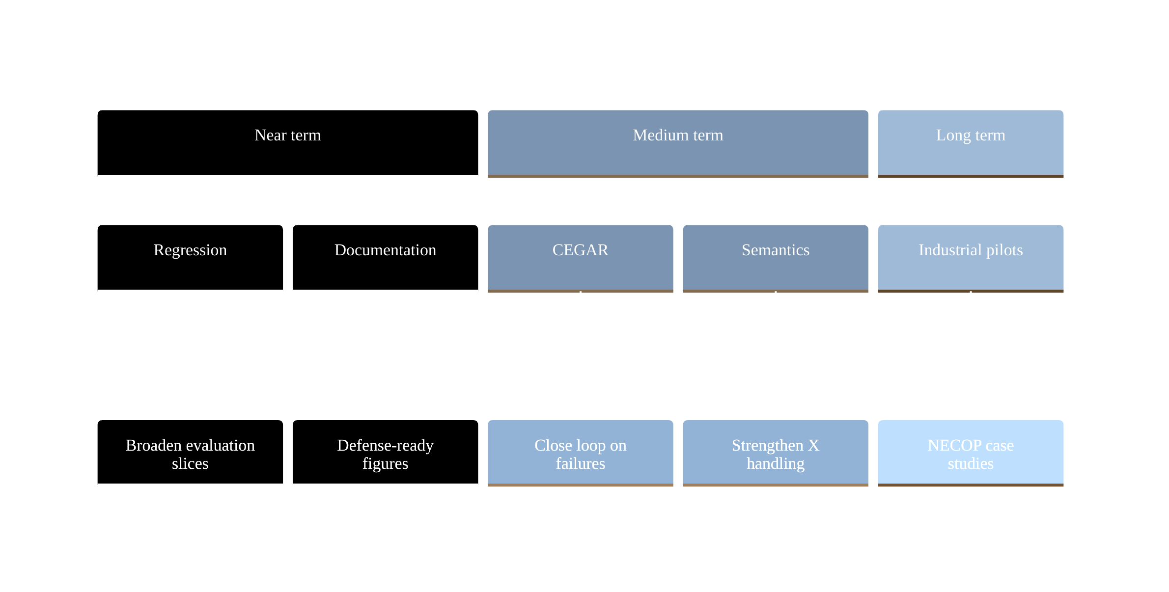
Figure 23 — diagram

GLOSSARY
Alphabetical technical terms (Heading 1 in Word). Expand or prune per faculty guidance.

Assertion
A Boolean or temporal expression checked during simulation or formal analysis.
In the VISTA context, Assertion appears when discussing toolchains, metrics, or deployment; cross-reference Chapter IV for operational meaning and Chapter V for empirical usage.

BMC
Bounded model checking: search for property violations up to a fixed temporal depth.
In the VISTA context, BMC appears when discussing toolchains, metrics, or deployment; cross-reference Chapter IV for operational meaning and Chapter V for empirical usage.

CEX
Counterexample: a witness trace showing how a property can fail.
In the VISTA context, CEX appears when discussing toolchains, metrics, or deployment; cross-reference Chapter IV for operational meaning and Chapter V for empirical usage.

Clocking
Rules that specify when signals and assertions are sampled.
In the VISTA context, Clocking appears when discussing toolchains, metrics, or deployment; cross-reference Chapter IV for operational meaning and Chapter V for empirical usage.

Coverage
Metrics indicating which design behaviors were exercised.
In the VISTA context, Coverage appears when discussing toolchains, metrics, or deployment; cross-reference Chapter IV for operational meaning and Chapter V for empirical usage.

Disable iff
SVA construct that suspends property evaluation under a condition.
In the VISTA context, Disable iff appears when discussing toolchains, metrics, or deployment; cross-reference Chapter IV for operational meaning and Chapter V for empirical usage.

Elaboration
Compilation phase that builds a netlist-like model from RTL.
In the VISTA context, Elaboration appears when discussing toolchains, metrics, or deployment; cross-reference Chapter IV for operational meaning and Chapter V for empirical usage.

FSM
Finite-state machine, often a target for temporal properties.
In the VISTA context, FSM appears when discussing toolchains, metrics, or deployment; cross-reference Chapter IV for operational meaning and Chapter V for empirical usage.

Formal
Mathematical analysis of a model against properties.
In the VISTA context, Formal appears when discussing toolchains, metrics, or deployment; cross-reference Chapter IV for operational meaning and Chapter V for empirical usage.

Gold reference
Expert or dataset-provided target output for comparison.
In the VISTA context, Gold reference appears when discussing toolchains, metrics, or deployment; cross-reference Chapter IV for operational meaning and Chapter V for empirical usage.

Harness
Wrapper module that supplies context for fragment-level RTL.
In the VISTA context, Harness appears when discussing toolchains, metrics, or deployment; cross-reference Chapter IV for operational meaning and Chapter V for empirical usage.

Induction
Proof technique generalizing from bounded unrolling.
In the VISTA context, Induction appears when discussing toolchains, metrics, or deployment; cross-reference Chapter IV for operational meaning and Chapter V for empirical usage.

Jaccard
Set overlap measure; here applied to token sets of assertions.
In the VISTA context, Jaccard appears when discussing toolchains, metrics, or deployment; cross-reference Chapter IV for operational meaning and Chapter V for empirical usage.

LoRA
Low-rank adaptation of weight updates in a subset of layers.
In the VISTA context, LoRA appears when discussing toolchains, metrics, or deployment; cross-reference Chapter IV for operational meaning and Chapter V for empirical usage.

PEFT
Parameter-efficient fine-tuning family including LoRA and QLoRA.
In the VISTA context, PEFT appears when discussing toolchains, metrics, or deployment; cross-reference Chapter IV for operational meaning and Chapter V for empirical usage.

Property
Named SVA construct grouping temporal behavior.
In the VISTA context, Property appears when discussing toolchains, metrics, or deployment; cross-reference Chapter IV for operational meaning and Chapter V for empirical usage.

QLoRA
Quantized LoRA training on a low-bit base model representation.
In the VISTA context, QLoRA appears when discussing toolchains, metrics, or deployment; cross-reference Chapter IV for operational meaning and Chapter V for empirical usage.

RTL
Register-transfer level hardware description.
In the VISTA context, RTL appears when discussing toolchains, metrics, or deployment; cross-reference Chapter IV for operational meaning and Chapter V for empirical usage.

Reset
Signal or protocol returning the design to a known state.
In the VISTA context, Reset appears when discussing toolchains, metrics, or deployment; cross-reference Chapter IV for operational meaning and Chapter V for empirical usage.

SMT
Satisfiability modulo theories used by many model checkers.
In the VISTA context, SMT appears when discussing toolchains, metrics, or deployment; cross-reference Chapter IV for operational meaning and Chapter V for empirical usage.

SVA
IEEE 1800 SystemVerilog Assertions language features.
In the VISTA context, SVA appears when discussing toolchains, metrics, or deployment; cross-reference Chapter IV for operational meaning and Chapter V for empirical usage.

SymbiYosys
Front-end driver for Yosys-based formal proof flows.
In the VISTA context, SymbiYosys appears when discussing toolchains, metrics, or deployment; cross-reference Chapter IV for operational meaning and Chapter V for empirical usage.

Temporal operator
Construct relating behavior across clock cycles.
In the VISTA context, Temporal operator appears when discussing toolchains, metrics, or deployment; cross-reference Chapter IV for operational meaning and Chapter V for empirical usage.

Token
Minimal text unit used in lexical similarity computation.
In the VISTA context, Token appears when discussing toolchains, metrics, or deployment; cross-reference Chapter IV for operational meaning and Chapter V for empirical usage.

VERT
Dataset pairing RTL fragments with reference assertions.
In the VISTA context, VERT appears when discussing toolchains, metrics, or deployment; cross-reference Chapter IV for operational meaning and Chapter V for empirical usage.

Vacuity
Situation where a property holds trivially and hides bugs.
In the VISTA context, Vacuity appears when discussing toolchains, metrics, or deployment; cross-reference Chapter IV for operational meaning and Chapter V for empirical usage.

Wrapper
Generated module enclosing dataset RTL for tools.
In the VISTA context, Wrapper appears when discussing toolchains, metrics, or deployment; cross-reference Chapter IV for operational meaning and Chapter V for empirical usage.

X-propagation
Behavior of unknown logic values through expressions.
In the VISTA context, X-propagation appears when discussing toolchains, metrics, or deployment; cross-reference Chapter IV for operational meaning and Chapter V for empirical usage.

Yosys
Open-source RTL synthesis and formal elaboration tool.
In the VISTA context, Yosys appears when discussing toolchains, metrics, or deployment; cross-reference Chapter IV for operational meaning and Chapter V for empirical usage.

Adapter weights
Trainable tensors added by LoRA/QLoRA to a frozen base.
In the VISTA context, Adapter weights appears when discussing toolchains, metrics, or deployment; cross-reference Chapter IV for operational meaning and Chapter V for empirical usage.

Batch size
Number of sequences processed per optimization step.
In the VISTA context, Batch size appears when discussing toolchains, metrics, or deployment; cross-reference Chapter IV for operational meaning and Chapter V for empirical usage.

Epoch
One full pass over the training split.
In the VISTA context, Epoch appears when discussing toolchains, metrics, or deployment; cross-reference Chapter IV for operational meaning and Chapter V for empirical usage.

Greedy filter
Iterative assertion retention subject to parse success.
In the VISTA context, Greedy filter appears when discussing toolchains, metrics, or deployment; cross-reference Chapter IV for operational meaning and Chapter V for empirical usage.

Inference
Forward pass of the model to generate new text.
In the VISTA context, Inference appears when discussing toolchains, metrics, or deployment; cross-reference Chapter IV for operational meaning and Chapter V for empirical usage.

Learning rate
Step size multiplier for gradient updates.
In the VISTA context, Learning rate appears when discussing toolchains, metrics, or deployment; cross-reference Chapter IV for operational meaning and Chapter V for empirical usage.

Perplexity
Exponentiated average negative log-likelihood on held-out text.
In the VISTA context, Perplexity appears when discussing toolchains, metrics, or deployment; cross-reference Chapter IV for operational meaning and Chapter V for empirical usage.

Quantization
Reduced numeric precision for weights or activations.
In the VISTA context, Quantization appears when discussing toolchains, metrics, or deployment; cross-reference Chapter IV for operational meaning and Chapter V for empirical usage.

Sequence length
Maximum tokens per training or inference example.
In the VISTA context, Sequence length appears when discussing toolchains, metrics, or deployment; cross-reference Chapter IV for operational meaning and Chapter V for empirical usage.

Supervised fine-tuning
Training on input–output pairs to imitate a task.
In the VISTA context, Supervised fine-tuning appears when discussing toolchains, metrics, or deployment; cross-reference Chapter IV for operational meaning and Chapter V for empirical usage.

Tokenizer
Component mapping text to model vocabulary indices.
In the VISTA context, Tokenizer appears when discussing toolchains, metrics, or deployment; cross-reference Chapter IV for operational meaning and Chapter V for empirical usage.

Unsloth
Training acceleration library used for LLaMA-family tuning.
In the VISTA context, Unsloth appears when discussing toolchains, metrics, or deployment; cross-reference Chapter IV for operational meaning and Chapter V for empirical usage.

Web client
Browser UI used in the VISTA demonstration.
In the VISTA context, Web client appears when discussing toolchains, metrics, or deployment; cross-reference Chapter IV for operational meaning and Chapter V for empirical usage.

FastAPI
Python web framework hosting inference in the demo stack.
In the VISTA context, FastAPI appears when discussing toolchains, metrics, or deployment; cross-reference Chapter IV for operational meaning and Chapter V for empirical usage.

Next.js
React framework used for the demonstration front end.
In the VISTA context, Next.js appears when discussing toolchains, metrics, or deployment; cross-reference Chapter IV for operational meaning and Chapter V for empirical usage.

OSS CAD Suite
Packaged open-source digital design tools including Yosys.
In the VISTA context, OSS CAD Suite appears when discussing toolchains, metrics, or deployment; cross-reference Chapter IV for operational meaning and Chapter V for empirical usage.

SDG
United Nations Sustainable Development Goal.
In the VISTA context, SDG appears when discussing toolchains, metrics, or deployment; cross-reference Chapter IV for operational meaning and Chapter V for empirical usage.

IEEE 1800
SystemVerilog language standard.
In the VISTA context, IEEE 1800 appears when discussing toolchains, metrics, or deployment; cross-reference Chapter IV for operational meaning and Chapter V for empirical usage.

NECOP
Industrial collaboration program supporting this project.
In the VISTA context, NECOP appears when discussing toolchains, metrics, or deployment; cross-reference Chapter IV for operational meaning and Chapter V for empirical usage.

GIKI
Ghulam Ishaq Khan Institute of Engineering Sciences and Technology.
In the VISTA context, GIKI appears when discussing toolchains, metrics, or deployment; cross-reference Chapter IV for operational meaning and Chapter V for empirical usage.

REFERENCES
Follow IEEE or Harvard style as required by the faculty (Harvard preferred where stated). Official citation guidance:
- IEEE Citation Reference: https://www.ieee.org/documents/ieeecitationref.pdf
- Harvard overview (external helpdesk link from institute template): http://www.noodletools.com/helpdesk/kb/index.php?action=article&id=53
Starter entries (complete and normalize in Zotero / Mendeley):
[1] IEEE Std 1800-2023, IEEE Standard for SystemVerilog.
[2] SymbiYosys documentation, https://symbiyosys.readthedocs.io/
[3] YosysHQ, Yosys, https://yosyshq.net/yosys/
[4] T. Dettmers et al., “QLoRA: Efficient Finetuning of Quantized LLMs,” arXiv:2305.14314, 2023.
[5] E. Halpern et al., “AssertionBench…,” arXiv:2406.18627, 2024.
[6] Unsloth, https://github.com/unslothai/unsloth
[7] VERT dataset — cite upstream source and license you relied upon.

APPENDIX A — Institute formatting checklist
Reproduce title page margins, subsequent-page margins, heading styles (CHAPTER I as Heading 1; chapter title as Heading 3; section headings per template), figure/table placement rules, equation numbering, and Turnitin submission per Vista_Report_format.txt.

APPENDIX B — Reproducibility statement
Quantitative claims refer to run model_eval_v7_100 in the project formal verification runs directory. The manifest records adapter path, decoding options, and per-index outcomes. Independent auditors should verify checksums and tool versions recorded at experiment time.

APPENDIX C — Ethics, risk, and limitations
Assertions may be incorrect or misleading despite passing bounded checks. Assumptions must be disclosed. RTL sent to third-party cloud APIs raises confidentiality risk; local execution mitigates this for the demonstration configuration described in Chapter IV.

Table A.1 — Outlier cases.
Index | SymbiYosys | Gold Jaccard | Notes
82 | fail | 1.0000 | Formal fail; don’t-care case item (Ch. V)
52 | pass | 0.9487 | Jaccard < 0.95; review overlap
9 | pass | 0.9375 | Jaccard < 0.95; review overlap
41 | pass | 0.9355 | Jaccard < 0.95; review overlap
46 | pass | 0.9355 | Jaccard < 0.95; review overlap
86 | pass | 0.9333 | Jaccard < 0.95; review overlap
24 | pass | 0.9310 | Jaccard < 0.95; review overlap
67 | pass | 0.9310 | Jaccard < 0.95; review overlap
96 | pass | 0.9310 | Jaccard < 0.95; review overlap
23 | pass | 0.9286 | Jaccard < 0.95; review overlap
40 | pass | 0.7576 | Jaccard < 0.95; review overlap

APPENDIX D — Extended threats to validity
Internal validity: the hundred-sample slice is not a random draw from all VERT; it is an early contiguous block chosen for reproducibility.
External validity: results may not transfer to full modules, different clocks, or commercial SVA subsets.
Construct validity: gold Jaccard measures lexical overlap, not full semantic entailment.
Conclusion validity: a single formal failure should be interpreted with the case study in Chapter V, not suppressed.

APPENDIX E — Table B.1 — Per-sample log (n = 100)
Index | Syntax OK | SymbiYosys | Gold Jaccard | Attempted clauses | Greedy dropped | Converted
1 | True | pass | 1.0000 | 3 | 0 | 3
2 | True | pass | 1.0000 | 8 | 0 | 8
3 | True | pass | 1.0000 | 3 | 0 | 3
4 | True | pass | 1.0000 | 3 | 0 | 3
5 | True | pass | 1.0000 | 3 | 0 | 3
6 | True | pass | 1.0000 | 4 | 0 | 4
7 | True | pass | 1.0000 | 8 | 0 | 8
8 | True | pass | 1.0000 | 4 | 0 | 4
9 | True | pass | 0.9375 | 7 | 0 | 7
10 | True | pass | 1.0000 | 8 | 0 | 8
11 | True | pass | 1.0000 | 3 | 0 | 3
12 | True | pass | 1.0000 | 3 | 0 | 3
13 | True | pass | 1.0000 | 4 | 0 | 4
14 | True | pass | 1.0000 | 3 | 0 | 3
15 | True | pass | 1.0000 | 3 | 0 | 3
16 | True | pass | 1.0000 | 5 | 1 | 4
17 | True | pass | 1.0000 | 4 | 0 | 4
18 | True | pass | 1.0000 | 5 | 1 | 4
19 | True | pass | 1.0000 | 5 | 1 | 4
20 | True | pass | 1.0000 | 8 | 0 | 8
21 | True | pass | 1.0000 | 4 | 0 | 4
22 | True | pass | 1.0000 | 3 | 0 | 3
23 | True | pass | 0.9286 | 7 | 0 | 7
24 | True | pass | 0.9310 | 7 | 0 | 7
25 | True | pass | 1.0000 | 4 | 0 | 4
26 | True | pass | 1.0000 | 4 | 0 | 4
27 | True | pass | 1.0000 | 3 | 0 | 3
28 | True | pass | 1.0000 | 8 | 0 | 8
29 | True | pass | 1.0000 | 4 | 1 | 3
30 | True | pass | 1.0000 | 5 | 1 | 4
31 | True | pass | 1.0000 | 3 | 0 | 3
32 | True | pass | 1.0000 | 8 | 0 | 8
33 | True | pass | 1.0000 | 2 | 0 | 2
34 | True | pass | 1.0000 | 3 | 0 | 3
35 | True | pass | 1.0000 | 4 | 0 | 4
36 | True | pass | 1.0000 | 8 | 0 | 8
37 | True | pass | 1.0000 | 5 | 1 | 4
38 | True | pass | 1.0000 | 3 | 0 | 3
39 | True | pass | 1.0000 | 2 | 1 | 1
40 | True | pass | 0.7576 | 6 | 0 | 6
41 | True | pass | 0.9355 | 8 | 0 | 8
42 | True | pass | 1.0000 | 3 | 1 | 2
43 | True | pass | 1.0000 | 8 | 0 | 8
44 | True | pass | 1.0000 | 3 | 0 | 3
45 | True | pass | 1.0000 | 6 | 1 | 5
46 | True | pass | 0.9355 | 7 | 0 | 7
47 | True | pass | 1.0000 | 3 | 0 | 3
48 | True | pass | 1.0000 | 8 | 0 | 8
49 | True | pass | 1.0000 | 3 | 0 | 3
50 | True | pass | 1.0000 | 2 | 0 | 2
51 | True | pass | 1.0000 | 3 | 0 | 3
52 | True | pass | 0.9487 | 4 | 0 | 4
53 | True | pass | 1.0000 | 3 | 0 | 3
54 | True | pass | 1.0000 | 3 | 0 | 3
55 | True | pass | 1.0000 | 3 | 0 | 3
56 | True | pass | 1.0000 | 6 | 1 | 5
57 | True | pass | 1.0000 | 3 | 0 | 3
58 | True | pass | 1.0000 | 6 | 1 | 5
59 | True | pass | 1.0000 | 3 | 0 | 3
60 | True | pass | 1.0000 | 2 | 0 | 2
61 | True | pass | 1.0000 | 8 | 0 | 8
62 | True | pass | 1.0000 | 4 | 0 | 4
63 | True | pass | 1.0000 | 3 | 0 | 3
64 | True | pass | 1.0000 | 4 | 0 | 4
65 | True | pass | 1.0000 | 3 | 0 | 3
66 | True | pass | 1.0000 | 3 | 0 | 3
67 | True | pass | 0.9310 | 7 | 0 | 7
68 | True | pass | 1.0000 | 3 | 0 | 3
69 | True | pass | 1.0000 | 4 | 0 | 4
70 | True | pass | 1.0000 | 8 | 0 | 8
71 | True | pass | 1.0000 | 3 | 0 | 3
72 | True | pass | 1.0000 | 4 | 0 | 4
73 | True | pass | 1.0000 | 4 | 0 | 4
74 | True | pass | 1.0000 | 4 | 0 | 4
75 | True | pass | 1.0000 | 3 | 0 | 3
76 | True | pass | 1.0000 | 4 | 0 | 4
77 | True | pass | 1.0000 | 3 | 0 | 3
78 | True | pass | 1.0000 | 8 | 0 | 8
79 | True | pass | 1.0000 | 4 | 1 | 3
80 | True | pass | 1.0000 | 4 | 0 | 4
81 | True | pass | 1.0000 | 8 | 0 | 8
82 | True | fail | 1.0000 | 4 | 0 | 4
83 | True | pass | 1.0000 | 4 | 0 | 4
84 | True | pass | 1.0000 | 4 | 0 | 4
85 | True | pass | 1.0000 | 3 | 0 | 3
86 | True | pass | 0.9333 | 7 | 0 | 7
87 | True | pass | 1.0000 | 8 | 0 | 8
88 | True | pass | 1.0000 | 2 | 1 | 1
89 | True | pass | 1.0000 | 3 | 0 | 3
90 | True | pass | 1.0000 | 4 | 0 | 4
91 | True | pass | 1.0000 | 5 | 1 | 4
92 | True | pass | 1.0000 | 8 | 0 | 8
93 | True | pass | 1.0000 | 8 | 0 | 8
94 | True | pass | 1.0000 | 8 | 0 | 8
95 | True | pass | 1.0000 | 8 | 0 | 8
96 | True | pass | 0.9310 | 7 | 0 | 7
97 | True | pass | 1.0000 | 4 | 0 | 4
98 | True | pass | 1.0000 | 4 | 0 | 4
99 | True | pass | 0.9667 | 7 | 0 | 7
100 | True | pass | 1.0000 | 4 | 0 | 4
Table footnotes (8 pt in Word): Greedy dropped counts assertions removed by the compatibility filter for that sample.
End of Draft 3 Markdown — regenerate with python scripts/build_vista_report_md.py and export with python scripts/export_report_to_docx.py (default output: exports/Draft 3.docx).

